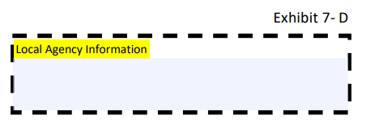MDH and WIC Logo

# Minnesota WIC Medical Data Form

Health Care Providers: Use this form to provide medical data to the WIC Program. Medical data may also be provided on a signed medical prescription form, signed letterhead, or other official medical record. Electronic option: scan the QR code to send the medical data.

QR code for Medical data


**Patient Demographics**

**Name: ­­­­­­­­­­­­­­­­­­­** _______________________ **Date of Birth: ­­­­­­­­­­­­­­­­­­**_____________________

**Medical Information**

## Date of Anthropometric Measurements: ______________

**Weight:**

lbs. oz. **or** kg. gm.

## Length/Height:

ft. in. **or** cm. mm. (Recumbent? Y/N)

## Date of Bloodwork Measurements: ______________

**Hgb:** g/dl **Hct:** %

**Health Professional Information**

**Health Professional’s Name:** ______________________________________

**Health Professional’s Signature:** ___________________________________

**Today’s Date:** __________ **Provider’s Phone Number:** _________________

**Clinic Name:** ___________________________________________________

*This institution is an equal opportunity provider.*

Minnesota Department of Health - WIC Program, 625 Robert St N, PO BOX 64975, ST PAUL MN 55164-0975; 1-800-657-3942, [health.wic@state.mn.us](mailto:health.wic@state.mn.us), [www.health.state.mn.us](http://www.health.state.mn.us/); to obtain this information in a different format, call: 1-800-657-3942.