How Can I Tell if the Water in My Home Has Too Much Lead?
There is no safe level of lead. If there is lead in your home environment, you should take steps to reduce your exposure. Many laboratories can test your water to see if it contains lead. Search for Accredited Laboratories (https://eldo.web.health.state.mn.us/public/accreditedlabs/labsearch.seam) to purchase a sample container and get instructions on how to submit a sample.
How Can I Test My Child for Lead Exposure?
If you are concerned about your child’s lead exposure, call your doctor, local health department, or the Minnesota Department of Health at 651-201-4620 or 800-657-3908 to find out how to have your child tested. Find out more information about child lead poisoning prevention by visiting Childhood Lead Exposures (https:/data.web.health.state.mn.us/web/mndata/lead).
Is My Water Still Safe to Use?
Before drinking your water, make sure you follow the actions recommended in the “How Can I Reduce My Exposure to Lead in Water?” section of this brochure.
You can safely use your water for cleaning, bathing, and other household uses.
Lead is everywhere in the environment. We recommend you take steps to minimize exposure to all sources of lead. Learn more at Lead in Drinking Water https://www.health.state.mn.us/communities/environment/water/contaminants/lead.html).
For More Information
For more information, call us at: ___- ___-____
Visit our website at: _______________
Visit the Minnesota Department Health website: Lead in Drinking Water (https://www.health.state.mn.us/communities/environment/water/contaminants/lead.html).
For more information on reducing lead exposure around your home/building and the health effects of lead, visit Lead (http://www.epa.gov/lead), or contact your health care provider.

This notice is being sent to you by
[Insert name of water system]
PWSID ___
Date Distributed: __/__/____
Important Information about Lead in
Your Drinking Water
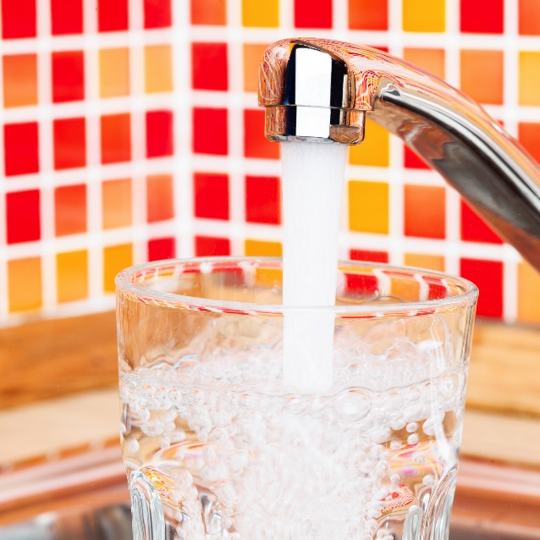
[Insert name of water system]
has found elevated levels of lead in drinking water in some homes/buildings.
Lead can cause serious health problems, especially for pregnant women and young children.
Please read this information closely to see what you can do to reduce lead in your drinking water.

What Are the Health Effects of Lead?
Lead can cause serious health problems if too much enters your body from drinking water or other sources. It can cause damage to the brain and kidneys, and can interfere with the production of red blood cells that carry oxygen to all parts of your body.
The greatest risk of lead exposure is to infants, young children, and pregnant women. Scientists have linked the effects of lead on the brain with lowered IQ in children.
Adults with kidney problems and high blood pressure can be affected by low levels of lead more than healthy adults. Lead can be stored in the bones, and it can be released later in life. During pregnancy, the child receives lead from the mother's bones, which may affect brain development.
What Are the Sources of Lead?
Lead is rarely found in natural sources of water such as rivers and lakes or underground aquifers.
You may be in contact with lead through paint, water, dust, soil, food, hobbies, or your job. The most common way for Minnesotans to come in contact with lead is through lead-based paint found in homes built before 1978. Visit Lead Poisoning Prevention: Common Sources (https://www.health.state.mn.us/communities/environment/lead/fs/common.html) to learn about how to reduce your contact with lead from sources other than your drinking water.
Lead can get into drinking water after it leaves the treatment plant, as it passes through your household plumbing system. Homes built before 1940 may have lead service lines that connect them to public water. Plumbing systems built before 1986 may have lead parts. New “lead free” pipes and plumbing parts may still contain 0.25% lead. Brass parts may also contain some lead. Note that many faucets are made of brass even if they do not have a “brass” color. The amount of lead that gets into in drinking water depends on many factors, such as the amount of lead in plumbing materials, water chemistry, and water usage.
How Can I Reduce My Exposure to Lead in Water?
- Let the water run before using it for drinking or cooking. If you have a lead service line, let the water run for 3-5 minutes. If you do not have a lead service line, let the water run for 30-60 seconds. The more time water has been sitting in your pipes, the more lead it may contain.
- You can find out if you have a lead service line by contacting your public water system, or by reading: Do you have lead pipes in your home? (https://apps.npr.org/find-lead-pipes-in-your-home/en/#intro)
- Ways to let the water run before using it for drinking or cooking:
  - Do household tasks like showering or running the dishwasher first
  - Collect tap water for cleaning or watering plants
- Make sure you let the water run from individual faucets for a short time before using them for drinking or cooking.
- Consider keeping a container of drinking water in the refrigerator to reduce how often you need to let the water run.
- Use cold water for drinking, making food, and making baby formula. Hot water releases more lead from pipes than cold water. Boiling water does not reduce lead levels and may actually increase them.
- Test your water. The only way to know if lead has been reduced by letting it run is to check with a test. If letting the water run does not reduce lead, consider other options to reduce your exposure.
- Treat your water or find an alternative source if a test shows your water has high levels of lead after you let the water run. You can learn more about water treatment options at Home Water Treatment (https://www.health.state.mn.us/communities/environment/water/factsheet/hometreatment.html).
What Did We Find?
[Name of water system] analyzed tap water samples taken from a number of locations [in the city, development, apartment building, manufactured home park, etc.]. Some of the samples were above the action level for lead.
What Are We Doing about the Issue?
[Add here an explanation for why lead levels are elevated, if this is known. For example, mention historical information on lead levels, if new construction is happening on the pipes or on your water treatment plant, etc.]

[Add here an explanation for what you are doing to address the lead problem, this could include: checking the water sources in the system for the presence of lead, implementing corrosion control strategies to make the water less likely to absorb lead from materials in the plumbing system, and exploring other sources, such as an alternative source of water. If your water system offers testing, include your contact information and anything else, such as if you provide free testing. You could also refer to other labs in your area that are certified to do water testing for lead.]

