High Consequence Infectious Disease (HCID) Readiness Binder
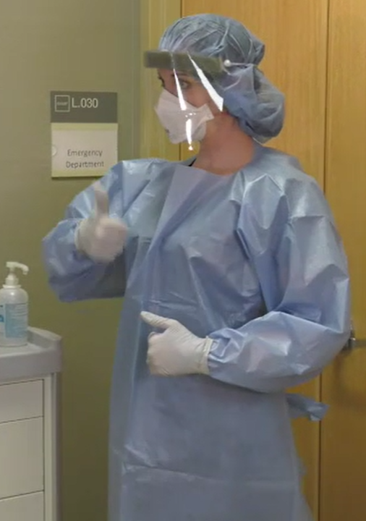
Minnesota Department of Health
Infectious Disease Epidemiology, Prevention and Control
PO Box 64975
St. Paul, MN 55164-0975
651-201-5414
health.icar@state.mn.us
www.health.state.mn.us
09/2019
To obtain this information in a different format, call: 651-201-5414.

High Consequence Infectious Disease (HCID) Management

This page is for the spine of the binder. Cut to fit binder width.

