e. Instructions for Donning and Doffing PPE:
HCID Level 2 – N95 Respirator Option
HIgh consequence infectious disease (HCID) Readiness binder
The following HCID Level 2 full barrier isolation personal protective equipment (PPE) is adapted from CDC guidance. It is to be used by health care providers (HCP) who are caring for patients with confirmed Ebola or other viral hemorrhagic fever (VHF) or persons under investigation (PUIs) for Ebola or other VHF who are clinically unstable or have bleeding, vomiting, or diarrhea.
These instructions are for PPE with a gown ensemble only. If coveralls are to be worn, these instructions can be edited by the facility to match CDC’s Guidance on Personal Protective Equipment (PPE) To Be Used By Healthcare Workers during Management of Patients with Confirmed Ebola or Persons under Investigation (PUIs) for Ebola who are Clinically Unstable or Have Bleeding, Vomiting, or Diarrhea in U.S. Hospitals, Including Procedures for Donning and Doffing PPE (https://www.cdc.gov/vhf/ebola/healthcare-us/ppe/guidance.html).
Facilities can rebrand and modify the instructions and images to match facility processes and guidelines.

Roles and Responsibilities
The health care provider (HCP) who will care for the patient:
- will wear surgical scrubs and washable footwear
- prior to donning, will hydrate in an area on the unit that is designated for eating and drinking and will also use the restroom
The trained observer:
- reviews the donning sequence with the HCP before the donning process
- reads the donning steps aloud to the HCP in a step-by-step fashion during the donning process
- uses this checklist to confirm visually that all PPE is donned correctly assure that all skin, hair, and clothing of the HCP is covered
The doffing assistant (buddy):
- will physically help the HCP with the doffing process if necessary

Supplies Needed
- Impermeable gown extending to mid-calf or a coverall (ANSI/AAMI level 4)
- Two pairs of extended cuff gloves in appropriate size
- Different color gloves can be helpful to identify a situation where one glove is accidentally removed or damaged
- N95 respirator
- Surgical hood that extends to shoulders and covers hair, ears, and neck
- Full face shield
- Impervious boots extending to just below the knee
- Apron in some circumstances
- A mirror can be useful for the HCP while donning PPE

Donning Instructions

Remove personal clothing and items
- HCP should wear surgical scrubs.
- No personal items should be worn under PPE or brought into the patient room (e.g., jewelry including rings, watches, cell phones, pagers, pens).
- Long hair should be tied back.
- Eye glasses should be secured with a tie.

Visually inspect PPE prior to donning
- All required PPE and supplies are available.
- PPE is in serviceable condition (e.g., not torn or ripped).
- Selected PPE sizes are correct for the HCP (e.g., gown to mid-calf, boots to just below knee, gloves fit).

Don boot covers

Perform hand hygiene

Don inner gloves with extended cuffs

Don gown (ANSI/AAMI level 4)
- Ensure gown is large enough to allow unrestricted movement.
- Ensure cuffs of inner gloves are tucked under gown sleeves.
- Secure all ties and fasteners.
- The trained observer will make any needed adjustments.

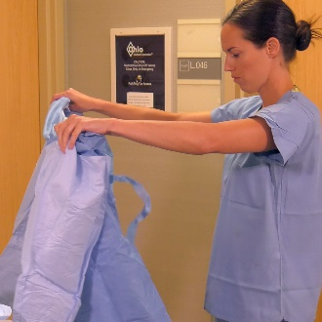
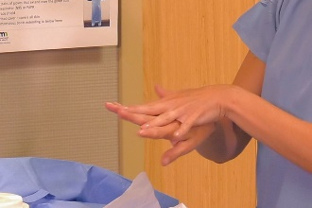
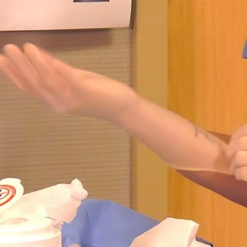
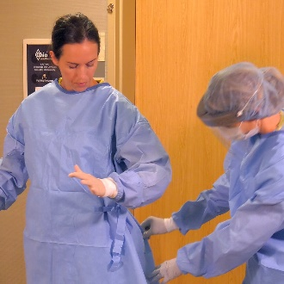

Don N95 respirator
- Complete a respirator seal check.

Don surgical hood over the N95 respirator
- The surgical hood should cover all the hair and ears and extend past the neck to shoulders.

Don apron (if not used, skip to step 10)
- Secure ties.
- Trained observer can help tie it in the back.

Don outer gloves with extended cuffs
- Ensure the cuffs are pulled over the gown sleeves.
- Trained observer can help pull extended cuff gloves over the gown sleeves.

Don face shield
- Put on full face shield over the N95 respirator and surgical hood to protect the eyes as well as front and sides of the face.

Verify
- The trained observer and HCP verify the integrity of the PPE ensemble (e.g., no cuts or tears).
- HCP should be able to go through a range of motion (e.g., extend arms, bend at waist) and remain correctly covered.
- HCP should have no exposed skin.

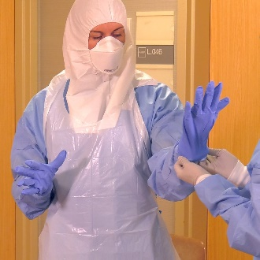
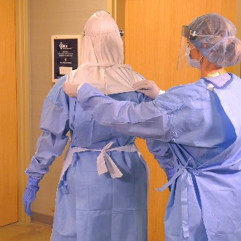

Doffing Instructions
- PPE should be doffed in the designated PPE removal area.
- The doffing area should be separated into sections where early and later steps of doffing are conducted (e.g., separate chairs or ends of a bench).
- All PPE waste is placed in a red bag inside a leak-proof infectious waste container.
- The trained observer and doffing assistant (buddy) should wear Level 1 Full Barrier PPE: fluid-resistant gown, two pairs of extended cuff gloves, regular face mask, full face shield (hair cover and booties are optional).
- The trained observer reads each step of the doffing process aloud to the health care provider (HCP) and reminds the HCP to avoid reflexive actions that may put them at risk such as touching their face.
- The trained observer does not physically help doff (does not touch the HCP).
- The doffing assistant (buddy) will physically assist the HCP with PPE doffing if needed.
- Wipes used in this process are EPA-registered disinfectant wipes.
- Alcohol-based hand rubs (ABHR) include any hand rub product that has greater than 60% alcohol.
- Either the infection preventionist or occupational health coordinator should meet with each HCP on a regular basis to review the patient care activities performed, identify any concerns about care protocols, and record the HCP’s level of fatigue.

Inspect
- HCP and trained observer inspect the PPE to assess for visible contamination, cuts, or tears before starting to remove PPE.
- If PPE is visibly contaminated, clean and disinfect using a disinfectant wipe.

Disinfect outer gloves
- Use a disinfectant wipe or ABHR and allow to dry.

Remove apron (if not used, skip to step 6)
- Remove by breaking neck strap and releasing waist ties.
- Roll the apron away from the body, containing the soiled outer surface as rolled.
- Discard the apron, taking care to avoid contaminating gloves or other surfaces.

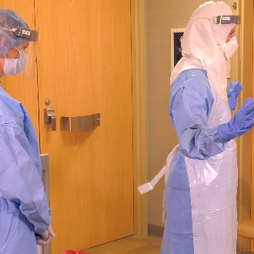
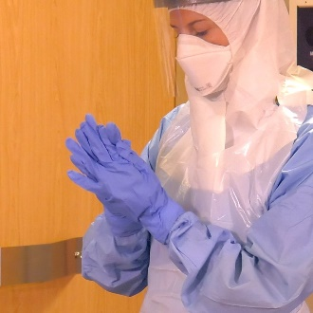
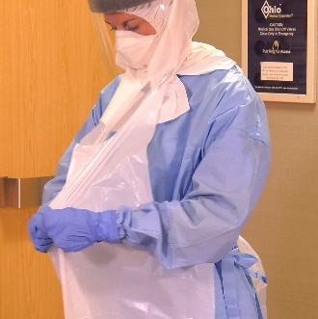

Inspect
- HCP and trained observer inspect the PPE ensemble for visible contamination, cuts, or tears.
- If PPE is visibly contaminated, clean and disinfect using a disinfectant wipe.

Disinfect outer gloves
- Disinfect outer gloves with a disinfectant wipe or ABHR and allow to dry.

Remove outer gloves
- Take care not to contaminate inner glove during removal process.
- Dispose in waste receptacle.

Inspect inner gloves
- HCP and trained observer inspect the inner gloves’ outer surfaces for visible contamination, cuts, or tears.
- If no visible contamination is identified on inner gloves, continue on to step 8.
- If an inner glove is visibly soiled, 1) disinfect gloves with a disinfectant wipe or ABHR, 2) remove inner gloves and perform hand hygiene on bare hands, and 3) don a new pair of gloves.
- If a cut or tear is detected on an inner glove, immediately review occupational exposure risk per hospital protocol.

Disinfect inner gloves
- Use a disinfectant wipe or ABHR and allow to dry.

Remove the full face shield
- Tilt heat slightly forward, grasp rear strap, pull it gently over the head, allow the shield to fall forward, and discard.
- Take care to not touch the face when removing the face shield.
- Avoid touching the front surface of the face shield.

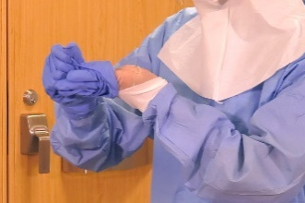
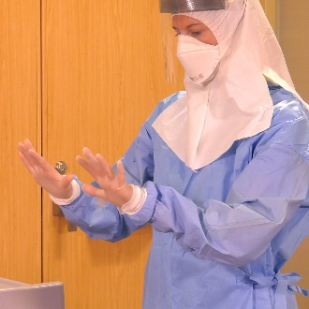
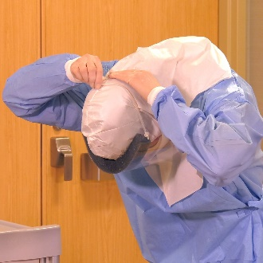

Disinfect inner gloves
- Use a disinfectant wipe or ABHR and allow to dry.

Remove surgical hood
- Unfasten surgical hood (if applicable).
- Gently remove and discard in waste receptacle.
- The doffing assistant (buddy) can assist with unfastening hood if it has ties.

Disinfect inner gloves
- Use a disinfectant wipe or ABHR and allow to dry.

Remove gown
- Depending on gown design and location of fasteners:
  - HCP can untie or gently break fasteners.
  - Or the doffing assistant (buddy) can unfasten gown.
- Pull gown away from body, folding inside out and touching only the inside of the gown.
- Avoid contact of scrubs or disposable garments with outer surface of gown during removal.

Disinfect inner gloves
- Use a disinfectant wipe or ABHR and allow to dry.

Remove boot covers
- Sit on a clean surface (e.g., second chair, clean side of bench).
- Pull off boot covers, taking care not to contaminate pant legs.

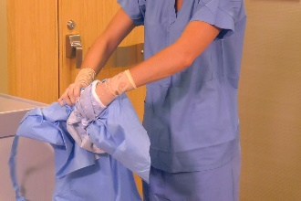
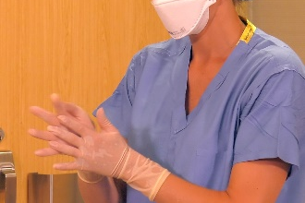
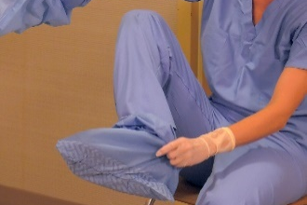

Disinfect inner gloves
- Disinfect inner gloves with a disinfectant wipe or ABHR and allow to dry.

Remove inner gloves
- Take care not to contaminate bare hands during removal process.
- Discard in waste receptacle.

Perform hand hygiene
- Perform hand hygiene on bare hands with ABHR and allow to dry.

Don a new pair of gloves

Remove N95 respirator
- Remove the N95 respirator by tilting head slightly forward.
- Grasp the bottom tie or elastic strap first, then the top tie or elastic strap.
- Remove without touching the front of the N95 respirator.
- Discard N95 respirator in waste receptacle.

Disinfect gloves
- Use a disinfectant wipe or ABHR and allow to dry.

Disinfect washable shoes
- Use a disinfectant wipe to wipe down every external surface of the washable shoes.
- Step out of the designated doffing area.
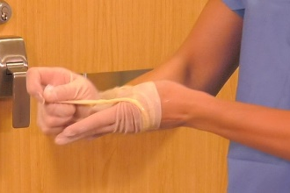

Disinfect and remove gloves
- Disinfect gloves with a disinfectant wipe or ABHR.
- Remove and discard gloves, taking care not to contaminate bare hands during removal process.

Perform hand hygiene
- Perform hand hygiene on bare hands with ABHR.

Inspect
- Both HCP and trained observer perform a final inspection for contamination of surgical scrubs or disposable garments.
- If contamination is identified, garments should be carefully removed and the HCP should shower immediately.
- Trained observer should immediately inform infection preventionist or occupational safety coordinator about the potential exposure.
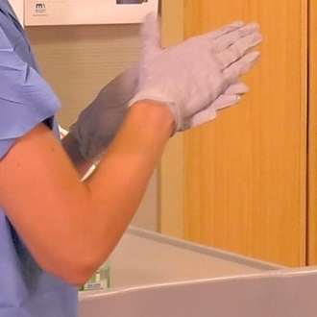
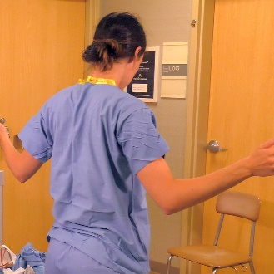

Scrubs
- HCP can leave the PPE removal area wearing dedicated washable footwear and surgical scrubs or disposable garments, proceeding to showering area where these are removed.

Protocol evaluation and medical assessment
- Either the infection preventionist or occupational health coordinator should meet with each HCP on a regular basis to review the patient care activities performed, identify any concerns about care protocols, and record the HCP’s level of fatigue.

Resources
The instructions above are adapted from CDC: Guidance on Personal Protective Equipment (PPE) To Be Used By Healthcare Workers during Management of Patients with Confirmed Ebola or Persons under Investigation (PUIs) for Ebola who are Clinically Unstable or Have Bleeding, Vomiting, or Diarrhea in U.S. Hospitals, Including Procedures for Donning and Doffing PPE (https://www.cdc.gov/vhf/ebola/healthcare-us/ppe/guidance.html).
CDC has short videos on donning and doffing each piece of PPE listed above.
- Visit CDC: Guidance for Donning and Doffing Personal Protective Equipment (PPE) During Management of Patients with Ebola Virus Disease in U.S. Hospitals (https://www.cdc.gov/vhf/ebola/hcp/ppe-training/index.html).
- Select type of PPE ensemble.
- Watch short video on donning or doffing individual piece of PPE.

Minnesota Department of Health
Infectious Disease Epidemiology, Prevention and Control
PO Box 64975
St. Paul, MN 55164-0975
651-201-5414
health.icar@state.mn.us
www.health.state.mn.us
09/2019
To obtain this information in a different format, call: 651-201-5414.

