Minnesota Department of Health

# CSFP Newsletter – Winter 2022

*Nutrition Information, Recipes and Resources for Minnesota Seniors*

## Staying Active

Minnesota winter months can make it challenging to stay active with the colder temperatures, fewer daylight hours and the snowy, slippery conditions.

You are never too old to exercise. It helps to keep the body strong and limber.1 Older adults who take part in strength and balance exercises can reduce their risk of falling by 33 percent2. Other benefits of exercise include:

* Reduce risk for many types of cancers
* Strengthen bones and muscles
* Lower blood pressure
* Maintain/lose weight
* Keep your mind sharp and focused as you get older

## Resources for Staying Active

* **At-Home Workouts:** If it’s too cold to go outside, you can still keep active indoors. Use resistance bands for stretching, light weights, yoga mat or an exercise ball, which are all relatively inexpensive.

**Community Classes:** Take a stretch class, enroll in yoga or senior volleyball. A community center near you may offer community exercise classes specifically for older adults. Check with your physician before starting any exercise program.

1eHealth. (6/6/19) Seven Medicare Advantage Benefits To Consider. <https://medicare.com/medicare-advantage/sevenmedicare-advantage-benefits-to-consider/>

2 Clemson Lindy, et. al; Integration of balance and strength training into daily life activity to reduce rate of falls in older people (the LiFE study): randomized parallel trial BMJ 2012.

Minnesota Department of Health - CSFP Program 85 E 7th Place, PO BOX 64882, ST PAUL MN 55164-0882; 651-201-4444, health.wic@state.mn.us, www.health.state.mn.us; To obtain this information in a different format, call: 651-201-4444

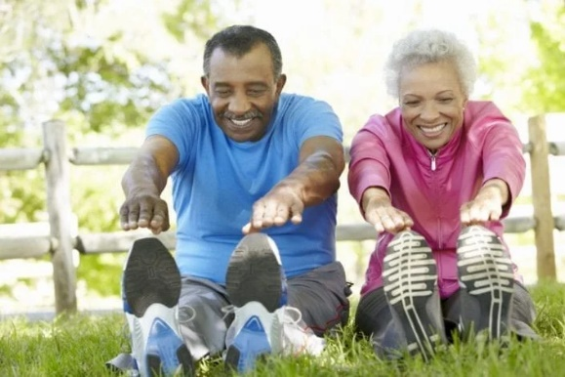

**Days to Celebrate!**

**January**

4th – National Spaghetti Day

6th – National Bean Day

9th – National Apricot Day

17th – Martin Luther King, Jr. Day

**February**

4th – Thank Your Mail Carrier Day

14th – Valentine’s Day

21st – President’s Day

24th – National Peanut Butter Day

**March**

American Red Cross Month

National Nutrition Month

14th – Pi Day

17th – St. Patrick’s Day

## Brown Rice is Diabetes “Nice”

Often people with Type 2 Diabetes shy away from including brown rice as part of their eating plan because it’s “too high” in carbohydrates. Although everyone’s needs are unique, rice can be a diabetes-friendly part of any diabetic’s nutrition intake.

**Rice is much more than just Carbohydrates:**

* It is a whole grain, meaning it retains the nutrient-packed bran and germ and is surprisingly nutritious.
* One cup of cooked brown rice contains more than 15 vitamins and minerals and about 14% of the Daily Value for fiber – making brown rice a good source of fiber1.
* Brown rice is high in manganese: this little known mineral is vital for bone development, wound healing, muscle contraction nerve function and blood sugar regulation2.
* Brown rice contains phenols and flavonoids, which are antioxidants that helps prevent cell damage to the good cells in the body3.
* Brown rice has a low glycemic load (how the body’s blood sugar responds to a food based on the grams of carbohydrates it has) won’t cause blood sugar to spike after consumption.
* Studies suggesting the antioxidants found in brown rice may be the reason for the low incidence of some chronic diseases in some areas of the world where rice is a staple food4.
* As always, check how you respond to any food you eat and consult with your Certified Diabetes Educator or Registered Dietitian.

1USARice.com/diabetes-rice

2,3Bowman AB, Kwakye GF, Herrero Hernández E, Aschner M. Role of manganese in neurodegenerative diseases. *J Trace Elem Med Biol*. 2011;25(4):191-203. doi:10.1016/j.jtemb.2011.08.144

2Goufo P, Trindade H. Rice antioxidants: phenolic acids, flavonoids, anthocyanins, proanthocyanidins, tocopherols, tocotrienols, γ-oryzanol, and phytic acid. *Food Sci Nutr*. 2014;2(2):75-104. doi:10.1002/fsn3.86

4Gong ES, Luo SJ, Li T, Liu CM, Zhang GW, Chen J, Zeng ZC, Liu RH. Phytochemical profiles and antioxidant activity of brown rice varieties. Food Chem. 2017 Jul 15;227:432-443.

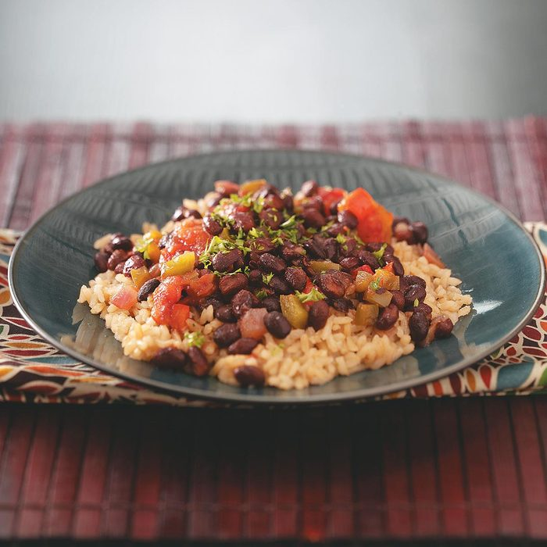

**Brown Rice with Black Beans**

**Ingredients:**

2 ½ c. cooked brown rice

2 cans black beans, rinsed/drained

1 can diced tomatoes, undrained

1 small green pepper, chopped

½ c. chopped red pepper

½ c. chopped yellow pepper

½ c. chopped red onion

2 Tbsp canola oil

2 Tbsp cider vinegar

½ tsp garlic salt

1/8 tsp pepper

1/8 tsp cayenne pepper

**How to Make It:**

In a large saucepan, sauté peppers and onion in oil until tender. Stir in beans, tomatoes, vinegar, garlic salt, pepper, and cayenne.

Bring to a boil. Reduce heat; simmer, uncovered, for 12-15 minutes, or until desired consistency, stirring occasionally.

Serve with the brown rice.