# RADON MITIGATION SYSTEM

# IMPORTANT SAFETY INFORMATION

A radon mitigation system was installed in this building to reduce radon levels. As the homeowner you are responsible for:

1. Making sure the radon levels are tested once the radon system is installed.
2. Checking system monitors monthly to be sure the system is operating correctly.
3. Retesting the building for radon at least every two years.

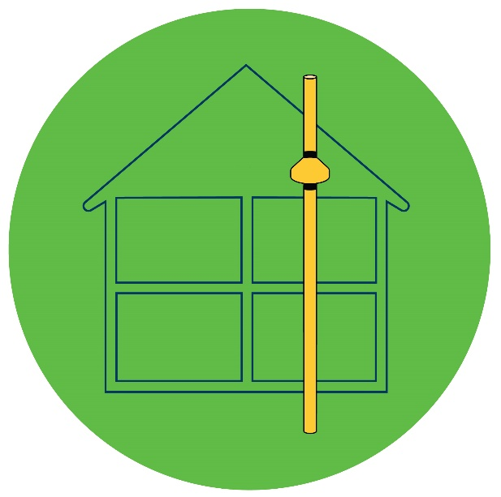

**Please read this document fully to understand how your radon system works and to understand what to do when it is not working properly. This document is required to be attached to the system for reference by current and future occupants. Please do not remove.**

**For service or questions call:**

**Company Name**:

**Address**:

**Email & Phone**:

**Installer’s Name**:

**MDH License Number**:

## Operation, Maintenance, and Monitoring Plan (OM&M Plan)

This information package is for the building owner or occupant and contains important information on how the radon mitigation system operates, how to maintain the system, and how to monitor it to make sure it continues to operate correctly. This type of system is called an active soil depressurization (ASD) system. It draws radon from the air below the building through a PVC pipe and vents it to the outside above the roof. This system uses a continuously running fan to draw the radon up through the pipe and prevent it from entering the home.

Specific information about the system installed in this building is included on a floor plan sketch or layout description included in this OM&M package. The description should include the location of system piping, suction points (where the radon pipe is inserted through the floor or sump basket cover), fan location, and any valve settings and locations if present. Copies of building or electrical permits should be available upon request.

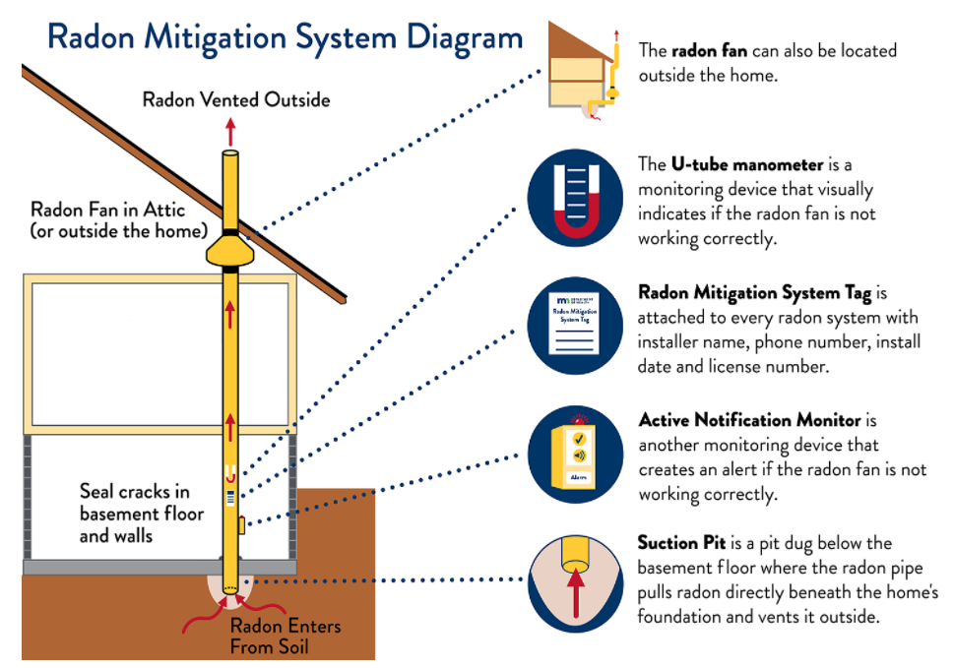

Minnesota Department of Health

Environmental Health | Indoor Air Unit | 651-201-4601 | <https://www.health.state.mn.us/radon>  
10/2/2023 | To obtain this information in a different format, call: 651-201-4601.

### Radon Mitigation System Fan Monitors

Every radon mitigation system is required to have two fan monitors: 1) a u-tube manometer and 2) an active notification monitor.

**U-Tube Manometer**

The u-tube manometer uses colored fluid in a tube to visually indicate the radon system is working. A small tube connects to a hole in the radon pipe and the suction from the fan pulls the fluid up. When the mitigation system is installed, the manometer reading is taken and written on a sticker located next to the u-tube manometer. This monitor does not show or measure radon levels, rather it shows there is suction in the pipe. If the fluid levels are even, it means the fan stopped working or another part of the system is not working properly.

**Active Notification Monitor**

The active notification monitor alerts you with a visual light and/or audible noise if the radon mitigation system stops working. The monitor either measures air flow or air pressure in the pipe. There are different monitoring devices with different features, so it is best to look at your monitor’s operational manual which is included in this OM&M package.

Both fan monitors should be checked monthly to make sure the mitigation system is working properly. The active notification monitor power source should be checked monthly as well since this could be plugged in or use batteries. If the manometer fluid levels are even or significantly different then when the system was installed, or if the active notification monitor alerts, the system may not be functioning properly. Before contacting the installer to service the system make sure the monitor tubing is connected to the pipe and not kinked, and that power is being supplied to the fan. If there is still an issue, contact the installer.

### Location of Radon Mitigation System Installed

A detailed narrative and/or a floor plan sketch is included for current and future occupants to understand the extent and location of the radon mitigation system installed in this building.

Floor plan sketch attached to OM&M document (Appendix A); OR

System layout narrative included below:

Number of suction point(s): Location(s):

Areas being depressurized:  basement floor  drain tile  sump  crawlspace

Other __

Pipe routed from/to:

Fan Model and setting: Location(s):

Vent termination point location(s):

Pipe valve location and setting:  N/A; or

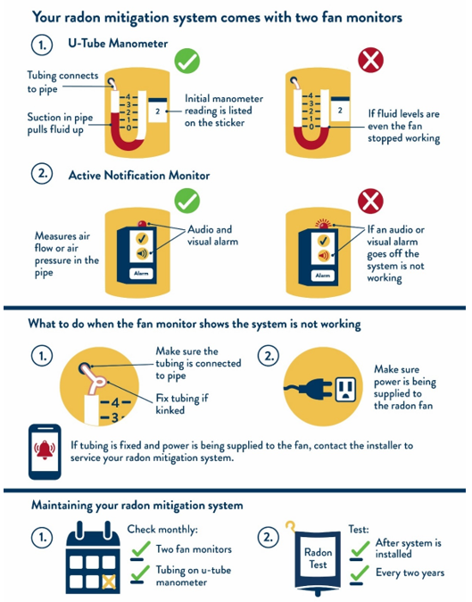

Minnesota Department of Health

Environmental Health | Indoor Air Unit | 651-201-4601 | <https://www.health.state.mn.us/radon>  
10/2/2023 | To obtain this information in a different format, call: 651-201-4601.

### When to Test and What the Test Results Mean

After a radon system is installed, it is required that a radon test be performed to make sure it is working properly and effectively reducing the radon levels. This testing can be done by a licensed radon mitigation professional, an independent licensed measurement professional, or a homeowner. To meet this retesting requirement, a short-term radon test needs to be done between 24 hours and 30 days after the radon mitigation system is installed.

After the initial retest is complete and the radon levels are low, it is important to continue to test the building every two years because radon levels can change. If possible,perform radon testing during the winter season, when the heating system is run throughout the day and night. This is more likely to give an accurate test result.

Information on what your radon test results mean and the action you should take based on the test results are below.

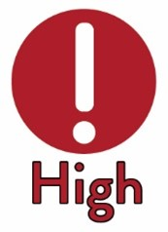

**If Test Results are 4.0 pCi/L or Greater**

Fix the building if test results indicate occupants may be exposed to radon concentrations that meet or exceed the Environmental Protection Agency’s action level of 4.0 pCi/L or above. If a radon mitigation system is already installed, then additional work may need to be performed to further lower the radon levels.



**If Test Results are Between 2.0 pCi/L and 4.0 pCi/L**

Consider fixing the building if the test result is above 2 pCi/L. If a radon mitigation system is already installed, then additional work may need to be performed to further lower the radon levels.

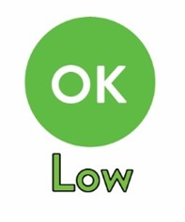

**If Test Result is 2.0 pCi/L or Below**

The radon levels are considered low.

### When to Retest

Retest every 2 years if you have a radon mitigation system installed to make sure it is still effectively lowering the radon levels. For buildings without a radon mitigation system, a retest is recommended every 5 years.

Testing to verify continued effectiveness is to be conducted in conjunction with any sale of a building and after any of the following events occur:

* New adjoining additions, structures, or parking lots;
* Building reconfiguration or rehabilitation;
* A ground contact area not previously tested is occupied or a home is newly occupied;
* Heating or cooling systems are altered with changes to air distribution or pressure relationships;
* Ventilation is altered by extensive weatherization efforts;
* Sizable openings to soil occur due to:
  + Groundwater or slab surface water control systems or sewer lines are added or altered. Examples include sumps, drain tiles, shower/tub retrofits, or
  + Natural settlement causing major cracks to develop.
* Earthquakes, blasting, fracking, or formation of sink holes nearby; or
* An installed mitigation system is altered.

### Radon Test Results

(Include test reports in OM&M packet if available)

Pre-mitigation: pCi/L Test location: Date

Installation date of radon mitigation system:

Post-mitigation: pCi/L Test location: Date

Retested Level: pCi/L Test location: Date

Retested Level: pCi/L Test location: Date

Retested Level: pCi/L Test location: Date

Retested Level: pCi/L Test location: Date

Retested Level: pCi/L Test location: Date

### Important Factors Affecting the Radon Mitigation System

Radon levels in a building can be affected by many different things. Below are some items that the homeowner should be made aware of that may affect the radon mitigation system or the radon levels and may need to be addressed in the future.

**Openings to the soil**

Some openings to the soil cannot be accessed or sealed by the licensed mitigation professional. This could make the radon system less efficient, less effective, or more costly to operate. In instances where this could not be done by the licensed mitigator it is noted below.

Openings to the soil under the basement bathtub/shower cannot be accessed to be sealed.

Large cracks in the floor that are covered and cannot be accessed to be sealed.

Gap between the floor and wall around the basement perimeter that cannot be completely sealed because it allows groundwater to drain into a waterproofing system.

Crawlspace areas or sections of the soil barrier cannot be accessed to be sealed.

Opening to a well casing within the building that must be sealed by a licensed contractor.

Other openings that cannot be sealed

**Air Exchanger**

Heat recovery ventilators (air exchangers) can greatly affect the radon levels in a building and can sometimes be used as, or in conjunction with, a radon mitigation system.

This building does not have an air exchanger.

An air exchanger is installed in this building and needs to always run at ____ setting to maintain lowered radon levels. Filters need to be cleaned and maintained as recommended by the manufacturer.

**System Freeze-up**

System freeze-up means there is an accumulation of ice in the pipe that does not allow radon to vent out of the pipe properly. Extended periods of cold temperatures can cause a system freeze-up. Radon levels in the building will increase if this happens. If this occurs the u-tube manometer fluid will be even and the active monitor should alert you. If this happens on a regular basis (annually or every few years) then the pipe will need to be insulated in unconditioned areas or other changes will need to be made to prevent a system freeze-up. Call the licensed installer to make these changes.

This vent pipe is insulated in the

This vent pipe is not insulated.

### Estimated Annual Operating Costs

The radon mitigation system fan continuously uses electricity, and the cost to run that fan is estimated below based on a price of $0.10 per kilowatt hour (kwh). This does not include additional energy costs that may occur because heated or cooled air from the building is vented to the outside by the radon mitigation system through unsealed openings to the soil.

Small fan (20 watts = $17.47 per year)

Medium fan (60 watts = $52.42 per year)

Large fan (150 watts = $131.04 per year)

Extra large fan or fans that are stacked (300 watts = $262.08 per year)

### Limitations of Work and Responsibilities

**Electrical Work** - If electrical work is necessary to power the fan, this is the responsibility of:

The radon mitigation company or their subcontractor

The property owner

**Initial Retest after System Installation** is the responsibility of:

The radon mitigation company or their subcontractor

The property owner

Licensed radon measurement professional

**Other Limitations** (*including**permanent sump pipe installation or extension, flexible sump pump piping replacement, drywall repair, spray foam installation, homeowner installed items, concrete patching, etc.)*

### Guarantees and Warranties

**Radon Reduction Guarantee**

The installed radon mitigation system:

is not guaranteed to reduce radon levels.

is guaranteed to reduce radon levels below pCi/L for years.

Conditions of the guarantee are  attached or  described below:

**System Warranty**

The installed system has a warranty: year on parts & year on labor.

Conditions of the warranty are  attached or  described below:

_______

### Appendix A: Floor Plan Sketch

### (Required if system narrative is not filled out on page 3)

For current and future occupants to understand the extent and location of the radon mitigation system installed in this building, a floor plan sketch and/or detailed narrative is included below. The system components including fan (note model and setting), all system piping, suction point location(s) and any valve settings are identified.

### Appendix B: Notice for Occupants in a Building with Attached Units:

There are inherent obligations to occupants of adjoining dwellings regarding disclosure of elevated radon concentrations and potential effects on adjoining dwellings after installation of a radon mitigation system.

In accordance with the ANSI/AARST standards, mitigation firms are obligated to advise the client of inherent obligations to neighboring occupants. It is strongly recommended to distribute the following message in writing to occupants of adjoining dwellings and, if applicable, to the homeowner’s association or management firm that provides stewardship for neighboring properties.

_

Notice to Neighboring Property Owners and Occupants

From:

Elevated radon concentrations were found at (addresses):

A mitigation system  has been installed, or  is planned to be installed.

In the interest of health protection, we have been advised to provide you the following messages:

1. Test your home for radon — it's easy and inexpensive. Any building on any parcel of land can have a radon problem.
2. The radon reduction system installed or planned for installation in our dwelling can inadvertently move air and extend a vacuum under some adjoining units or dwellings with the intent to stop radon entry into your dwelling. It is recommended that occupants of adjoining units:
   1. Seek to maximize radon reductions and energy conservation by closing openings to soil (e.g., closed covers over sumps and large holes).
   2. Check for any adverse impacts such as flue gas spillage from combustion appliances.
3. We cannot warrant any degree of radon reductions, nor can we be responsible for maintaining radon reductions, maximizing energy conservation, or checking for unlikely yet possible environmental impacts for adjoining units.

For additional guidance, it is recommended to contact the state or local radon office. Sources include the National Radon Hotline at 1-800-SOS-RADON (1-800-767-7236) and the Minnesota Department of Health at 651-201-4601 and at mn.gov/radon.