Minnesota Department of Health

# Public Notice Passage Language Translations

MHD has translated the following passage “This report contains important information about your drinking water. Have someone translate it for you or speak with someone who understands it.” To the following languages listed below. To complete appropriate public notice multi-lingual requirements, you may need to copy and paste the text or image below to include in your public noticing method.

## Spanish

Información importante. Si no la entiende, haga que alguien se la traduzca ahora.

## Amaric

This picture, amh.png, contains Amharic text which states the following: This report contains important information about your drinking water. Have someone translate it for you, or speak with someone who understands it. 

## Arabic

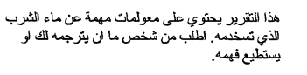

## Cambodian (Khmer)

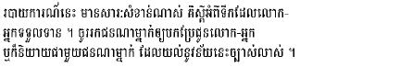

## Chinese (Mandarin)

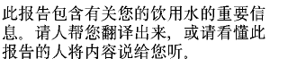

## French

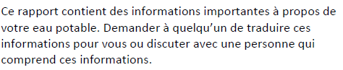

## Hmong

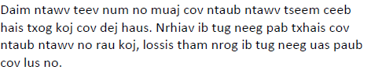

## Karen

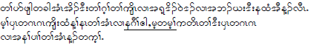

## Laotian

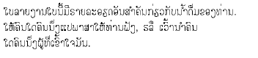

## Oromo

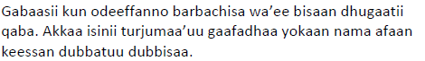

## Russian

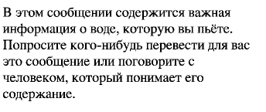

## Somali

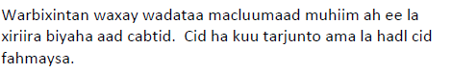

## Vietnamese

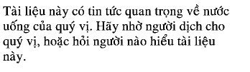

Minnesota Department of Health  
Drinking Water Protection Program  
651-201-4700   
[www.health.state.mn.us](http://www.health.state.mn.us)

June 2023

To obtain this information in a different format, call: 651-201-4700.