(Example Cover Letter and Application)
City of Bootheville
P.O. Box 137
Bootheville, Minnesota xxxxx
bootheville@gofast.net

February 6, 2020
Minnesota Department of Health
DWRF Program
P.O. Box 64975
St. Paul, Minnesota 55164-0975
Dear Revolving Fund Coordinator,
Enclosed is the Bootheville proposal to place the watermain and lead service line replacement project on the fiscal year 2021 Drinking Water Revolving Fund Project Priority List.
Thank you for your consideration.
Sincerely,
Jean Boothe, Mayor
Enclosures
cc: Janet Meyers, Meyers Planning and Engineering

Drinking Water Revolving Fund Application
(Example Application)

Project Priority List

Project Owner
City of Bootheville

Project Name
Treatment Plant Addition & Rehabilitation
Watermain Replacement and Looping
Lead Service Line Replacement

Contacts

City Representative
Jack Leech, City Administrator
City of Bootheville
P.O. Box 137
Storm Prairie, MN xxxxx
507-860-xxxx
bootheville@gofast.net

Proposal Writer
Janet Meyers
Meyers Planning & Engineering
468 Geek Avenue
Slide Rule, MN xxxxx
320-439-xxxx
j.meyers@for.hire.org

Community Statistics & Population
Bootheville is located in Buffalo County, Minnesota. Incorporated in 1869, the economy was based on agriculture and light industry. A recent distribution center has added 40 new full time jobs. The company is expecting to double the number of employees in the next five years.
Current Population: 1283
Current Households: 513
Projected 2030 Population: 1345
2019 Median Household Income: $38,472

System description

General
The public water system consists of two municipal wells, an iron & manganese filtration plant, one elevated storage tank, and a distribution system that serves all developed properties within the corporate city limits. The average water use in 2019 was 240,050 gpd, and the maximum water use was 552,114 gpd. Many of the water service lines in the older part of town are lead. All service connections are metered.

Supply
Well #2 is a shallow drift well, approximately 85 feet deep. In the last few years the production has declined from 180 to 130 gallons per minute. Well #2 has very low concentrations of iron and manganese and an ammonia concentration of 0.3 mg/L. Well #1 was sealed when Well #2 was drilled in 1968.
Well #4 draws water from the Jordan aquifer and is approximately 210 feet deep. The water is high in iron and manganese and has non-detectable levels of ammonia. Well #4 replaced Well #3, which was sealed in 1986.
Well Information
Well | Constructed | Depth | Capacity | Iron | Manganese | Ammonia
#2 | 1968 | 85 Feet | 130 GPM | 0.05 mg/L | 0.01 mg/L | 0.3 mg/L
#4 | 1985 | 210 Feet | 400 GPM | 1.0 mg/L | 0.1 mg/L | Non-detect

Treatment
The iron & manganese filtration plant was built in 1986 to treat water from Well #4 at a capacity of 400 gallons per minute. The treatment process consists of aeration followed by filtration through anthracite/greensand media. Water from Well #2, which is low in iron and manganese, is blended with the treated water from the plant before entering the distribution system. Chemical treatment consists of sodium permanganate, gas chlorine, fluoride and orthophosphate. The system practices breakpoint chlorination to burn off the ammonia from Well #2.
Contaminant | Raw Water from Well #4 (mg/L) | Finished Water (mg/L) | Secondary Drinking Water Standard (mg/L)
Iron | 1.0 | 0.03 | 0.3
Manganese | 0.1 | 0.01 | 0.05

Storage
Water is stored in a 300,000 gallon elevated storage tank located on Park Street. It was built in 1992. It is in good condition based on last year’s inspection but will likely need to be recoated within the next five to ten years.

Distribution
The community is served by cast and ductile iron watermain. Most lines are four, six, and eight inches in diameter. The cast iron lines are primarily in the central area of town and were installed in the early 1930’s. The ductile iron watermain, which was installed in the 1970’s is located on the north and south sides of town. The central area of town also has many lead service lines remaining. During a recent survey, 43 lead services were found in the older part of town that need to be replaced.

Need for Improvements

Source
Well #2 is nearing the end of its useful service. Capacity has declined 28%. In 1998 the well was rehabilitated and production went up, but it has since declined to its current level of 130 gallons per minute.
The Minnesota Department of Health recommends a community have pumping capacity equal to the average daily consumption with the largest well out of production. Bootheville does not currently meet this standard if Well #4 is not in operation. The city would like to replace Well #2 in the next few years but does not plan to address it as part of this proposal.

Treatment
The treatment plant is old, equipment is crowded, and the plant has never been dehumidified. The pipes are corroded, and the filter equipment has severe pitting. Filter media needs to be replaced, and the chemicals need separate rooms to meet current safety standards. The city would like to expand and rehabilitate the treatment plant as soon as possible.

Distribution
The city is planning on repaving Main Street next year. The Main Street watermain was installed in the early 1930’s. There have been several watermain breaks in the last year along Main Street. One of the breaks resulted in a loss of pressure and caused the city to issue a Drinking Water Advisory. The city would like to replace the watermain and sanitary sewer in conjunction with the street repaving project. The city has applied to the Clean Water Revolving Fund for the sanitary sewer replacement.
The city would also like to eliminate several dead end water lines on the south side of town by looping watermain in that area. Numerous complaints associated with stagnant water have been received from residents on Third Avenue and on the south side of town.

Lead Service Lines
As mentioned above, the city has found several lead service lines along Main Street. The city only owns the service line to the curb stop but would like to replace both the private and public portion of all 43 lead service lines in conjunction with the watermain project.

Alternatives
The city would like to list the treatment plant rehabilitation, watermain replacement, watermain looping, and lead service line replacement projects on the Project Priority List at this time.

Treatment
The following alternatives were evaluated for the existing treatment plant:
- Treatment Plant Addition & Rehabilitation – The rehabilitation will include the addition of chemical rooms, and replacement of all chemical feed equipment, package gravity filter, process piping, pumping equipment, HVAC and mechanical components as well as all necessary maintenance of the building. Estimated cost - $1,654,275
- New 400 gpm Treatment Plant with Package Gravity Filters – This option would include constructing a new treatment plant with a package gravity filter. The new plant would have similar characteristics to the current treatment plant with additional rooms to provide storage for incompatible chemicals. Estimated cost - $2,100,000.
- New 400 gpm Treatment Plant with Pressure Filters – This option would include constructing a new treatment plant with pressure filters. The new plant would have similar characteristics to the current treatment plant with additional rooms to provide storage for incompatible chemicals. The well pumps would also need to be upgraded to handle the additional head requirements of the pressure filters. Estimated cost - $2,400,000.
- Do nothing. The plant will continue to deteriorate to the point that a rehabilitation is not possible.

Distribution
The following alternatives were evaluated for the watermain distribution system:
- Replace Watermain under Main Street and Loop – Replace the old cast iron watermain under Main Street when the street repair is being done as well as loop the dead end watermains in the south part of town to provide better water quality.
Estimated cost - $2,656,500
- Only Replace Watermain under Main Street – Only replace the old cast iron watermains under Main Street during the street repair project without addressing the dead end lines on the south end of town. Estimated cost - $2,300,000
- Only Loop Dead Ends – Only loop the dead end watermains to provide better water quality. Watermain under Main Street would be lined at a later time.
Estimated cost - $350,000
- Do Nothing – People will continue to complain. Repairs will be ongoing for Main Street. Replacement costs will increase after Main Street has been repaved.

Lead Service Line Replacement
- Replace Lead Service Lines – Fully replace all 43 lead service lines in the project area in hopes to get a 50 percent grant for the resident’s portion of the service line.
Estimated cost - $225,750
- Continue City’s Standard Practice – Continue to optimize corrosion control treatment while encouraging residents to replace their portion of the lead service. The city will replace the city portion if the resident chooses to replace their portion of the lead service line.

Alternative Selected
Treatment – Treatment Plant Addition & Rehabilitation – Based on the cost comparison of the options, the city would like to upgrade and expand the existing treatment plant footprint to bring it up to current standards. The building itself is in good condition and has at least 50 years of useful life left if it is properly maintained. It is also conveniently located to the city shop.
Distribution – Replace Watermain under Main Street and Loop – Due to the timing of the repaving project, the city believes now is the best time to complete the watermain replacement on Main Street. They would also like to tie the looping project in the watermain replacement project.
Lead Service Line Replacement – The city would like to fully replace all lead service lines in the project area.

Cost Summary
Treatment Plant Addition and Rehabilitation - $1,654,275
Description | Cost
Construction Cost | $1,370,000
Engineering & Admin (15%) | $ 205,500
Contingency (5%) | $ 78,775
Total | $1,654,275
Replace Watermain under Main Street & Loop - $2,656,500
Description | Cost
Replacement Construction Costs | $1,900,000
Looping Construction Costs | $ 300,000
Engineering & Admin (15%) | $ 330,000
Contingency (5%) | $ 126,500
Total | $2,656,500
Lead Service Line Replace - $225,750 (engineering & admin included with watermain project)
Description | Cost
Replace 43 lead service lines @ $5,000 each | $215,000
Contingency | $ 10,750
Total | $225,750

Project Schedule

Treatment Plant
Engineering Plans and Specifications: February 2021
Bid Project: April 2021
Award Contract: May 2021
Begin Construction: June 2021
Substantial Completion: July 2022
Final Completion: September 2022

Watermain Replacement, Looping and Lead Service Line Replacement
Engineering Plant and Specification: January 2021
Bid Project: March 2021
Award Contract: April 2021
Begin Construction: May 2021
Substantial Completion: July 2022
Final Completion: September 2022

Water Supply Plan
A plan was submitted to the Minnesota Department of Natural Resources in January 2018. It was reviewed, revisions were made, and the plan was approved in August 2019.

Miscellaneous
A city map is attached. The red lines highlight the replacement location along Main Street as well as the area intended to be looped.
Bootheville City Map
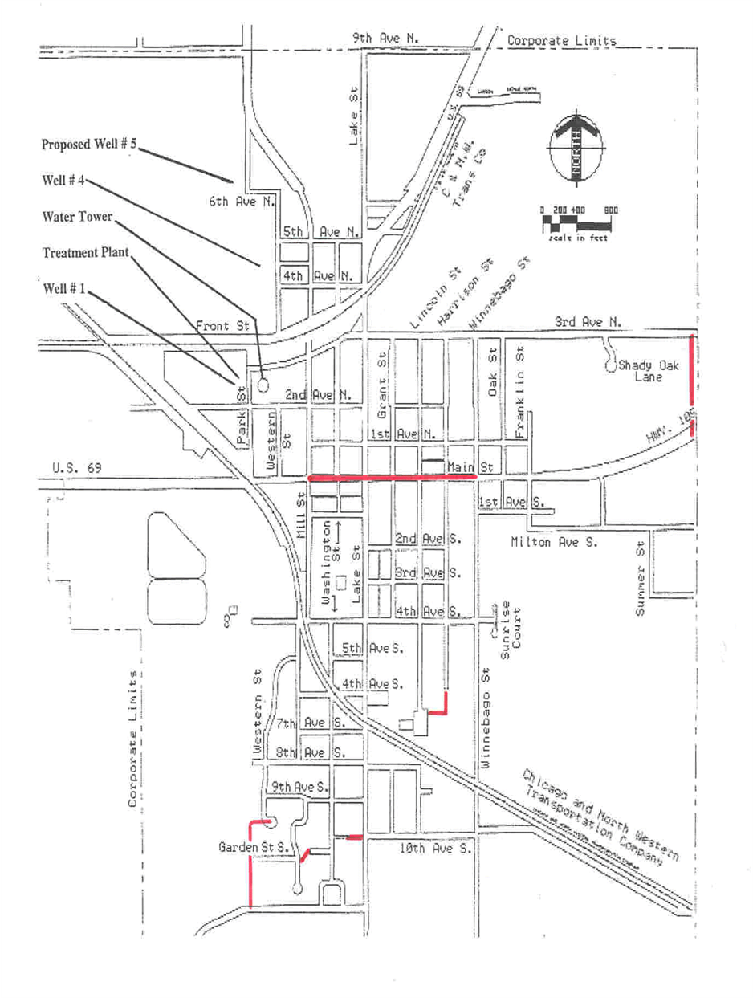
Minnesota Department of Health
Drinking Water Protection
651-201-4700

