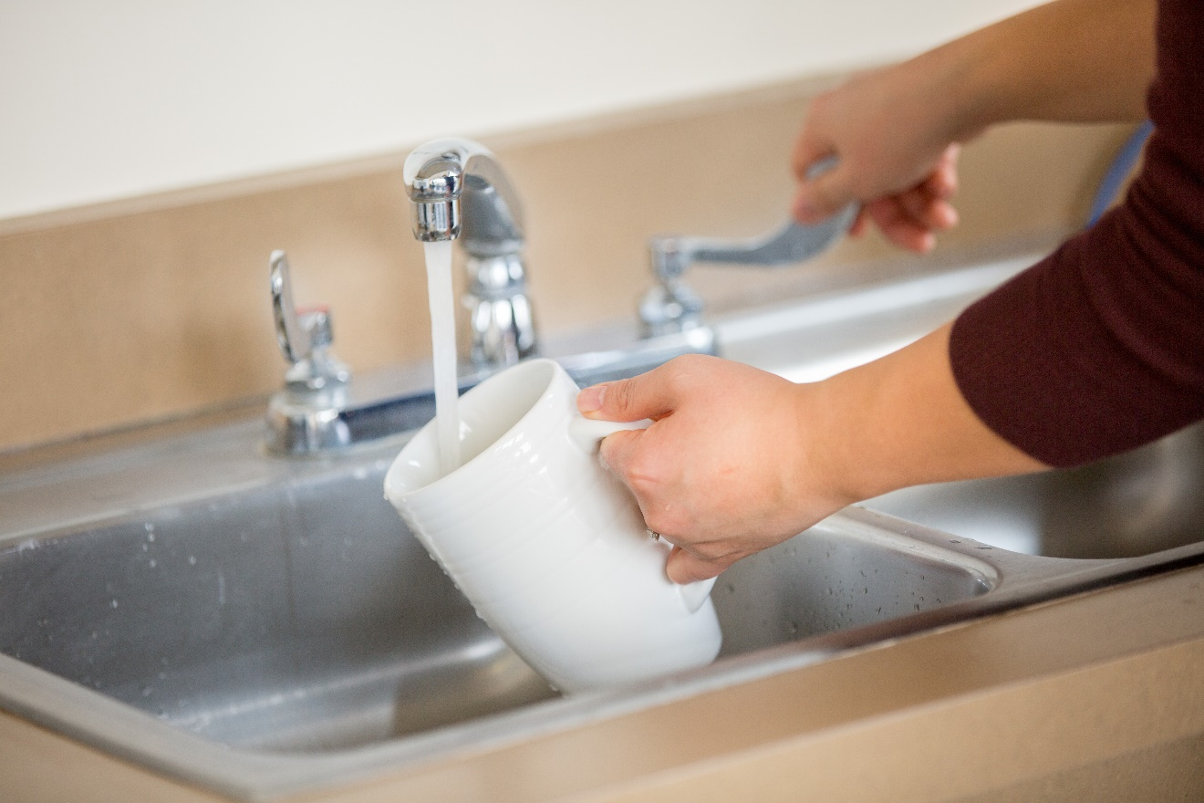

**Make sure your well water is safe to drink.**

Order a test kit today.

**Make sure your well water is safe to drink.**

Order a test kit today.

Insert laboratory name/logo

Insert laboratory name/logo

Laboratory Name

Address

City, State ZIP

Laboratory Name

Address

City, State ZIP

As a private well user, you are responsible for regularly testing your well water to make sure it is safe for everyone in your home to drink.

(Insert local entity with water testing recommendations.) recommends testing private well water for:

* Aaa
* Bbb
* Ccc
* Ddd

Contact [Insert lab name] to get a test kit, starting at $XX.

As a private well user, you are responsible for regularly testing your well water to make sure it is safe for everyone in your home to drink.

(Insert local entity with water testing recommendations.) recommends testing private well water for:

* Aaa
* Bbb
* Ccc
* Ddd

Contact [Insert lab name] to get a test kit, starting at $XX.

Presort Standard

US Postage

PAID

Permit No. XXX  
City, ST

Presort Standard

US Postage

PAID

Permit No. XXX  
City, ST