Minnesota Department of Health

# Health Advisory: Sedative Associated Overdoses

Minnesota Department of Health, Tue, July 29 10:00 CDT 2025

## Action Steps

**Local and tribal health department**: Please forward to hospitals, clinics, urgent care centers, and emergency departments in your jurisdiction.   
**Hospitals, clinics and other facilities**: Please forward to all health care providers who may work with people who use drugs.   
**Health care providers**:

* Focus on restoring the breathing of overdose patients, rather than restoring their consciousness.
* Consider naloxone administration to treat suspected drug overdose in patients experiencing combined respiratory insufficiency and unresponsiveness to reverse the effects of opioids such as fentanyl or heroin.
* Monitor breathing and be aware that non-opioid sedatives such as xylazine and medetomidine do not directly respond to naloxone.
* Treat opioid withdrawal and sedative withdrawal simultaneously with clinically directed and evidence-based medications.
* Join the Minnesota Drug Overdose and Substance Use Surveillance Activity (MNDOSA) to help MDH share data from hospital partners about statewide drug trends.
* Get Involved with the [Minnesota Drug Overdose and Substance Use Surveillance Activity (MNDOSA) (https://www.health.state.mn.us/communities/injury/data/mndosa.html)](https://www.health.state.mn.us/communities/injury/data/mndosa.html) to help MDH collect and share data about statewide drug trends.

## Situation Update

Following nationwide trends, Minnesota has seen a rise in overdoses associated with non-opioid sedatives like xylazine and medetomidine. While drug traffickers may add these sedatives to their drug supplies to reduce costs or modify the substances’ effects, the people who use illicit substances often do not know what they are taking or the risks involved. **The presence of non-opioid sedatives mixed into other drugs significantly complicates the treatment of overdose patients.**

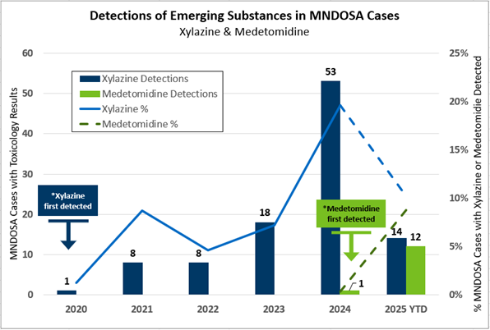 Source: Minnesota Drug Overdose and Substance Use Surveillance Activity Data (MNDOSA), Division of Injury Prevention and Mental Health, Minnesota Department of Health, 2020-2025.

Toxicology testing from overdose patients treated at participating emergency departments across Minnesota has detected increasing numbers of sedative associated overdose cases since 2020, when xylazine overdoses were first recorded. In 2024, MDH began detecting medetomidine, another sedative in the same class as xylazine and with similar effects. This testing is done through MNDOSA, which currently partners with eight hospitals across Minnesota. These data provide a snapshot of substance exposures, which can vary by region and may not represent all Minnesota communities.

## Sedative Associated Overdose Symptoms and Pharmacology

Veterinary sedatives like xylazine and medetomidine are being found mixed into opioids, nearly always in presence of fentanyl. Since these sedatives are not opioids, they will not respond directly to naloxone. **Naloxone should still be considered and administered to restore adequate breathing and may help improve unresponsiveness if the latter is due to opioid toxicity.** However, providers and first responders should be aware that sedatives may cause people to remain sedated.

While medetomidine toxicity and withdrawal have been described, this information is limited in humans. Some of the effects described have been consistent with those observed with therapeutic use and withdrawal of the similar FDA approved medication dexmedetomidine.

## Overdose Response and Withdrawal Treatment

Health providers should consider the possibility of exposure to sedatives when patients presenting with an overdose do not respond to naloxone. In these situations, provide supportive respiratory care and proper management of blood pressure. Overdose response should focus on restoring adequate respiratory status including breathing. Consciousness may not improve in the setting of sedative toxicity.

Sedative use, when stopped abruptly, can lead to severe withdrawal symptoms, including anxiety, irritability, restlessness, and hypertension. If admitted for inpatient care, clinicians must be prepared to manage sedative associated withdrawal symptoms simultaneously with opioid withdrawal.

## For More Information

* [MDH Minnesota Drug Overdose and Substance Use Surveillance Activity (MNDOSA) (https://www.health.state.mn.us/communities/injury/data/mndosa.html)](https://www.health.state.mn.us/communities/injury/data/mndosa.html)
* [MN Poison Control Center (https://mnpoison.org/)](https://mnpoison.org/)
* [Philadelphia HAN: Medetomidine, a potent non-opioid veterinary sedative, has been detected in the illicit drug supply (https://hip.phila.gov/document/4421/PDPH-HAN-0441A-05-13-24.pdf)](https://hip.phila.gov/document/4421/PDPH-HAN-0441A-05-13-24.pdf/)
* [Chicago HAN: Medetomidine in Chicago’s Drug Supply May 20, 2024 (https://www.chicagohan.org/alert-detail/-/alert-details/46684184)](https://www.chicagohan.org/alert-detail/-/alert-details/46684184)
* [MMWR: Overdoses Involving Medetomidine Mixed with Opioids (https://www.cdc.gov/mmwr/volumes/74/wr/mm7415a1.htm?s_cid=mm7415a1_w)](https://www.cdc.gov/mmwr/volumes/74/wr/mm7415a1.htm?s_cid=mm7415a1_w)
* [AP: Animal sedative medetomidine is showing up in the US illegal drug supply, CDC says (https://apnews.com/article/cdc-animal-sedative-medetomidine-40e02b935d1c37189da4b9cd6ccd3210)](https://apnews.com/article/cdc-animal-sedative-medetomidine-40e02b935d1c37189da4b9cd6ccd3210)

A copy of this HAN is available at: [MDH Health Alert Network (www.health.state.mn.us/communities/ep/han/)](https://www.health.state.mn.us/communities/ep/han)  
The content of this message is intended for public health and health care personnel and response partners who have a need to know the information to perform their duties.