Hospital Nuclear Surge Exercise in a Box
  - Situation Manual
[Insert Date Here]

This Situation Manual (SitMan) provides exercise participants with all the necessary tools for their roles in the exercise. Some exercise material is intended for the exclusive use of exercise planners, facilitators, and evaluators, but players may view other materials that are necessary to their performance. All exercise participants may view the SitMan.

Exercise Overview
Exercise Name | Hospital Nuclear Surge Exercise in a Box
Exercise Dates | [Insert date and time here]
Scope | This exercise is a tabletop exercise, planned for [#] hours at the [location]. Exercise play is limited to [insert participants here].
Mission Area(s) | Response
HPP Capabilities | Capability 2: Health Care and Medical Response Coordination  - Objective 1: Develop and Coordinate Health Care Organization and Health Care Coalition Response Plans  - Objective 3: Coordinate Response Strategy, Resources, and Communications  Capability 3: Continuity of Health Care Service Delivery  - Objective 3: Maintain Access to Non-Personnel Resources during an Emergency  - Objective 5: Protect Responders’ Safety and Health  - Objective 6: Plan for and Coordinate Health Care Evacuations and Relocation  Capability 4: Medical Surge  - Objective 1: Plan for a Medical Surge  - Objective 2: Respond to a Medical Surge
Objectives | - Describe processes for staff to activate a nuclear or hospital surge plan and support functions.  - Clarify the communication processes for [Facility] to coordinate operations with MDH, [jurisdiction’s emergency management agency], and other jurisdictional response stakeholders.  - Describe how [facility] will deal with an influx of pediatric patients before transportation to a pediatric hospital can be achieved.  - Applying nuclear processes, tools, and protocols, discuss how the hospital with deal with an influx of patients while also dealing with a loss of critical infrastructure.
Threat or Hazard | Nuclear/Radiological
Scenario | A 20 kt nuclear detonation occurred at the state fair grounds at 12:00 pm. The blast zone extended 13 miles beyond the epicenter of the blast. Approximately 100,000 people were on the grounds and have been affected by the detonation and/or exposed to radiation. The metro coalition has begun to notify hospitals they will be receiving an above average load of patients within the next 30 to 90 minutes.
Sponsor | [Insert jurisdiction name]
Participating Organizations | See Appendix A for a complete list of participants.
Point of Contact | [Insert name, title, organization, and contact information]

General Information

Exercise Objectives and HPP Capabilities
The following exercise objectives in Table 1 describe the expected outcomes for the exercise. The objectives are linked to HPP capabilities, which are distinct critical elements necessary to achieve the specific mission area(s). The objectives and aligned HPP capabilities are selected by the Exercise Planning Team.
Exercise Objective | HPP Capability
Describe processes for staff to activate a nuclear or hospital surge plan and support functions. | Capability 4: Medical Surge  •Objective 2: Respond to a Medical Surge
Clarify the communication processes for [Facility] to coordinate operations with MDH, [jurisdiction’s emergency management agency], and other jurisdictional response stakeholders. | Capability 2: Health Care and Medical Response Coordination  •Objective 1: Develop and Coordinate Health Care Organization and Health Care Coalition Response Plans  •Objective 3: Coordinate Response Strategy, Resources, and Communications
Describe how [facility] will deal with an influx of pediatric patients before transportation to a pediatric hospital can be achieved. | Capability 4: Medical Surge  •Objective 2: Respond to a Medical Surge
Applying nuclear processes, tools, and protocols, discuss how the hospital with deal with an influx of patients while also dealing with a loss of critical infrastructure. | Capability 2: Health Care and Medical Response Coordination  •Objective 3: Coordinate Response Strategy, Resources, and Communications

Table 1. Exercise Objectives and Associated HPP Capabilities

Participant Roles and Responsibilities
The term participant encompasses many groups of people, not just those playing in the exercise. Groups of participants involved in the exercise, and their respective roles and responsibilities, are as follows:
- Players. Players are personnel who have an active role in discussing or performing their regular roles and responsibilities during the exercise. Players discuss or initiate actions in response to the simulated emergency.
- Observers. Observers do not directly participate in the exercise. However, they may support the development of player responses to the situation during the discussion by asking relevant questions or providing subject matter expertise.
- Facilitators. Facilitators provide situation updates and moderate discussions. They also provide additional information or resolve questions as required. Key Exercise Planning Team members also may assist with facilitation as subject matter experts (SMEs) during the exercise.
- Evaluators. Evaluators are assigned to observe and document certain objectives during the exercise. Their primary role is to document player discussions, including how and if those discussions conform to plans, polices, and procedures.

Exercise Structure
This exercise will be a multimedia, facilitated exercise. Players will participate in the following three modules:
- Module 1: Activation of Nuclear Surge Plan
- Module 2: Stakeholder Communication
- Module 3: Influx of Pediatric Patients
- Module 4: Infrastructure loss

Module One exercise participants will discuss the events leading up to activation of the nuclear surge plan, how the plan gets activated, and how the facility will get ready for a surge of patients. Participants will review the situation and engage in discussion using the series of questions provided.
In Module Two, exercise participants will discuss issues of stakeholder information sharing during a nuclear surge incident. Participants will review the situation and engage in discussion using the series of questions provided.
In Module Three, participants will discuss the processes and procedures that will need to be implemented in the event, a nuclear incident effects a pediatric population. This will also be discussed through the lens of non-pediatric hospitals needing to care for pediatric patients and what considerations are needed.

Exercise Guidelines
- This exercise will be held in an open, low-stress, no-fault environment. Varying viewpoints, even disagreements, are expected.
- Respond to the scenario using your knowledge of current plans and capabilities (i.e., you may use only existing assets) and insights derived from your training.
- Decisions are not precedent setting and may not reflect your organization’s final position on a given issue. This exercise is an opportunity to discuss and present multiple options and possible solutions.
Issue identification is not as valuable as suggestions and recommended actions that could improve response efforts. Problem-solving efforts should be the focus.

Exercise Assumptions and Artificialities
In any exercise, assumptions and artificialities may be necessary to complete play in the time allotted and/or account for logistical limitations. Exercise participants should accept that assumptions and artificialities are inherent in any exercise and should not allow these considerations to negatively impact their participation. During this exercise, the following apply:
- There will be much more activity going on across the US and greater Minnesota in the scenario depicted in this exercise. Players will need to discuss collaboration with other facilities, jurisdictions, and agencies throughout the state.
- The exercise is conducted in a no-fault learning environment wherein capabilities, plans, systems, and processes will be evaluated.
- The exercise scenario is plausible, and events occur as they are presented.
- All players receive information at the same time.

Exercise Evaluation
Evaluation of the exercise is based on the exercise objectives and aligned HPP capabilities and critical tasks which are documented in Exercise Evaluation Guides (EEGs). Evaluators have EEGs for each of their assigned areas. Additionally, players will be asked to complete participant feedback forms. These documents, coupled with facilitator observations and notes, will be used to evaluate the exercise and compile the After-Action Report (AAR).

Module 1: Activation of Nuclear Surge Plan “operations”

Saturday of Labor Day Weekend
A 20 kt nuclear detonation just occurred at the state fair grounds at 12:00 pm. It is unclear if it was a surface or airburst explosion, but assumed to be a surface detonation, which means there will be radioactive fallout. State Fair attendance is being reported as 225,000 people today and it’s expected that up to 100,000 people have been injured or exposed to radiation.

Current weather has winds at SE at 15 mph headed towards St. Paul. This means Regions Hospital, Gillette Children’s, United Hospital, Children’s of Minnesota St. Paul Campus, and St. Joseph’s Hospitals are in the fallout zone. These hospitals are locked down, sheltering in place, and will be unable to accept or transfer patients for at least 12 hours.

MNDOT has assessed the bridges crossing the Mississippi River in Minneapolis and all are sound except for the I-94 bridge. I-94 is closed between Riverside Ave and Snelling Ave. Access to the University of Minnesota-East & West Bank exits are not accessible from I-94, but hospitals are open and fully functioning.

The Metro Coalition just notified your facility there will be a large influx in patients. Many patients will have trauma or burn injuries, as well as dealing with acute radiation syndrome (ARS) patients. It is possible ARS patients will continue to come into the hospital emergency department 24-48 hours after the initial event and surge.

Minnesota Radiation Injury Treatment Network Hospitals
- University of Minnesota
- Mayo Clinic Rochester
  - The vast majority of patients (approximately 70%) will require diagnostic monitoring to determine the level of Acute Radiation Syndrome which may be managed at an outpatient site.
  - Only 10% of the total casualties from the detonation of an IND will have radiation only injuries and therefore be appropriate for RITN centers.

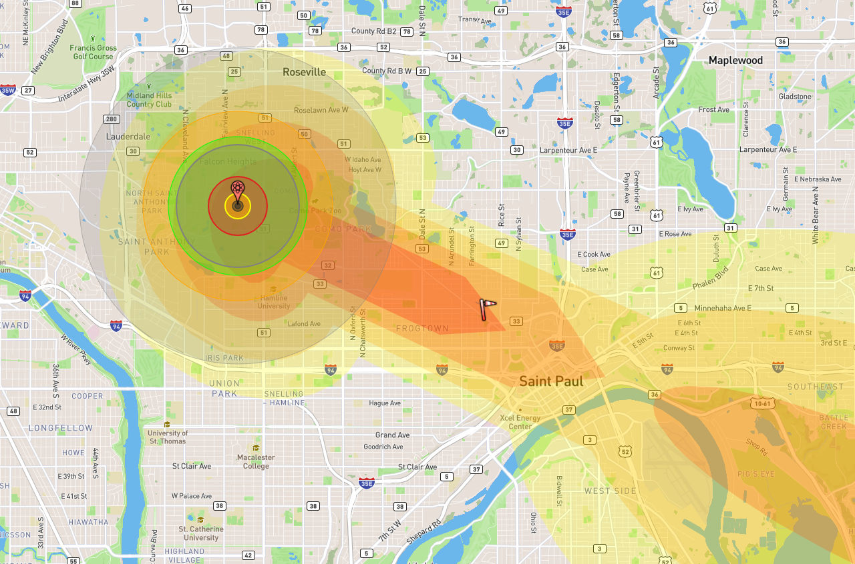

Group Discussion
Based on the information provided above, and using the questions below, assign a scribe in your group and have a discussion for the next 30 minutes. Identify any critical issues, decisions, requirements, or questions that should be addressed at this time.
- How will the nuclear/radiation surge plan be activated?
- How will the facility be set up to deal with an influx of trauma, burn, and radiation injury patients? How will all needed supplies be obtained?
- Who is responsible for accepting the initial triaging of patients? How will it be decided who can be treated, or who need to be transported elsewhere?
- How will decontamination of patients be handled?
- Who is the trauma, burn, or radiological specialist for your facility? If they are not physically at the facility, or able to get to the facility how will communication work?
- How will staff be prepared for behavioral health issues they may experience or encounter in patients? How will patients be provided with behavioral health support? Is there someone on site to help support staff?
- Is there enough PPE for staff, if not where/how will you get enough? What will you do if you are unable to get extra PPE?
- Who manages your laboratory, and will they have enough supplies and staff to quickly perform required CBC with differentials? If not, do you have an alternate plan?

Notes:

Module 2: Stakeholder Communication

[Date and Time Here]
Timely ongoing communication with MDH, HCCs and other stakeholders is critical. [Hospital] must coordinate with EMS regarding the transportation of patients. [Hospital] must also coordinate with law enforcement if necessary, regarding security issues and must keep local elected officials informed during this unprecedented response.

Group Discussion
Based on the information provided above, and using the questions below, assign a scribe in your group and have a discussion for the next 30 minutes. Identify any critical issues, decisions, requirements, or questions that should be addressed at this time.
- How will staff at the hospital communicate and coordinate with the jurisdiction’s emergency management agency and/or DOC?
- What is the ideal role for local elected officials in this scenario? How will they be kept informed?
- What types of events or triggers would prompt you to reach out to MDH? What method(s) would you use to communicate with MDH?
- If needed, how will you communicate and coordinate with local law enforcement?
- What types of information will need to be shared with health care partners and how will it be shared? What is the role of the health care coalition in sharing this information?
- What types of communication will be shared with the public?

Notes:

Module 3: Influx of Pediatric Patients

[Date and Time Here]
Due to the nature of where the nuclear incident occurred, at the state fairgrounds in Saint Paul, Como Zoo was affected. The Zoo was in the light damage zone, as well as on the edge of the radiation/thermal radiation radius. There are up to 25,000 pediatric injuries between the Fairgrounds and the zoo. The number of pediatric patients will overwhelm the children’s hospitals, and non-pediatric hospitals will need to assist in taking care of children. Children’s of Minnesota St. Paul campus and Gillette are unable to accept patients for the initial 12 hours due to radioactive fallout.

Group Discussion
Based on the information provided above, and using the questions below, assign a scribe in your group and have a discussion for the next 30 minutes. Identify any critical issues, decisions, requirements, or questions that should be addressed at this time.
- If necessary, how many pediatric patients can [Hospital] care for? What types of patients can you are for? Trauma? Burn? Radiation?
- How will pediatric patients be triaged?
- Do you have a pediatric doctor who can come in and take care of children in your hospital?
- If needed, could you communicate with a pediatric hospital nearby to consult with other physicians about patients, prior to transferring to a pediatric hospital when available?
- Are there special considerations your ER needs to help treat pediatric patients? To transfer patients?
- How would you deal with reuniting families?
- Do you have/know correct pediatric dosing of medications?
- How do you treat a pediatric patient with acute radiation sickness (ARS)?
- How to deal with post-traumatic stress from the incident with children? Is there a child psychologist on call?

Notes:

Module 4: Infrastructure Loss

[Date and Time Here]
The surge of patients is starting to arrive at local hospitals. However, due to the nature of the attack, there are critical parts of the state infrastructure that has been affected.

Group Discussion
Based on the information provided above, and using the questions below, assign a scribe in your group and have a discussion for the next 30 minutes. Identify any critical issues, decisions, requirements, or questions that should be addressed at this time.
- How will you communicate without cell phone service?
  - How could you get other physicians/nurses/staff into the hospital to help with the surge?
  - How would you communicate with family members, or get in contact with family members? (Hospital staff and when dealing with patients)
- How will you deal with communicating with EMS?
  - What if radio communication if affected?
- What are the protocols if power is lost?
  - Does loss of power affect treatment? Treatment for ARS?
- Depending on the season, what are the protocols for loss of heat or air conditioning?
- What are the protocols if water is off, or there is not safe water?
- Does the hospital have enough food provisions in the event food trucks can’t get in for a week?

Notes:

Next Steps/ Assignments (Hot Wash):
Discuss the following questions immediately after the exercise and take notes to inform your After Action Report:
- Which processes need additional work to be operational?

- Which partners do we need to do more work to coordinate with?

- Which trainings need to be given in advance? Which just-in-time training materials are needed?

- What information isn’t in the MDH guidance that you still need?

- What are the action steps to address the issues you’ve identified? Who is responsible for each action step?

Other notes:

Appendix a: Exercise Participants
Participating Organizations

