Racial Equity Assessment
Complete this assessment worksheet to analyze and plan for major policy, program, budget or practice changes to be in alignment with the department’s racial equity goals and desired outcomes. This analysis should be completed by people with different racial perspectives.

Project/initiative Name:
Description:
Department:
Contact:
This is a:

- Policy
- Initiative
- Program
- Budget Issue

Step 1. Set outcomes.
Leadership communicates key community outcomes for racial equity to guide analysis.
1a. For your department, what are the most important racial equity community outcomes related to the issue? (Response should be completed by department leadership in consultation with lead department staff(s) on policy/ program/budget or practice)
1b. What is your proposal and how does your proposal relate to these outcomes?
1c. Which racial equity opportunity area(s) will this primarily impact?

- Community & Economic Development
- Public Works
- Environment/Sustainability
- Public Safety
- Jobs
- Housing
- Transportation
- Contracting Equity
- Workforce Equity
- Fire
- Safety and Inspections
- Education /youth work
- Parks and Recreation
- Other: ____________________________

Step 2. Involve stakeholders. Analyze data.
Gather information from community and staff on how the issue benefits or burdens the community in terms of racial equity.
2a. Are there impacts on specific geographic areas? Yes No
Check all neighborhoods that apply (see City map on page 7):

- All Saint Paul neighborhoods
- CapitolRiver/Downtown
- Como
- Dayton's Bluff
- Eastview/Conway/Battle Creek/Highwood Hills
- Frogtown/Thomas-Dale
- Greater East Side
- Hamline-Midway
- Highland
- Macalester-Groveland
- North End/South Como
- Payne-Phalen
- St. Anthony Park
- Summit Hill
- Summit-University
- Union Park
- West 7th/Fort Road
- West Side

- Outside of the city (please explain):

2b. What are the racial demographics of residents in the area or who are impacted by the issue? (See neighborhood demographic data on pages 5 and 6. Remember to also take into consideration the community members of that area who may not necessarily live there.)
2c. How have you involved community members and stakeholders in discussing, planning, developing or reviewing this proposal? Please provide details. If you have not yet involved the community members and stakeholders in discussing, planning, and developing this proposal, how do you plan to do so? (See Engaging Stakeholders on page 6.) * In order for this guide to be most effective, conduct your stakeholder engagement process before proceeding.*
2d. What do your conversations with external stakeholders and data you’ve gathered tell you about existing racial inequities in the targeted community? Be specific.

Step 3. Benefits or burdens.
Given what you have learned from data and from stakeholder involvement…
3a. What benefits may result because of this proposal?
3b. Are there unintended negative consequences i.e., burden falls disproportionally on low-income and/or communities of color?
3c. Are you accomplishing what you set out to do in Step 1 of your analysis? If not, how you can minimize harm or change your proposal so your work is not creating greater racial inequity.

Step 4. Short- and long-term strategies to eliminate inequities.
Develop strategies to create greater racial equity or minimize unintended consequences.
4.a. What are your short-term strategies to reach your desired racially equitable outcomes? How will you measure and track your progress?
4.b. What are your long-term strategies to reach your desired racially equitable outcomes? How will you measure and track your progress?

Step 5. Raise racial awareness. Be accountable.
Track impacts on communities of color overtime. Continue to communicate with and involve stakeholders. Document unresolved issues.

5a. What issues or racial inequities are unresolved? What resources/partnerships do you still need to make changes?
5.b. How will you share information learned from this analysis with your department? How will you raise awareness about racial inequity related to this issue at the city?
5. c. How will you share your analysis and final plan or proposal with community stakeholders?

ADDITIONAL RESOURCES

ENGAGING STAKEHOLDERS
(adapted from City of Seattle’s Racial Equity Toolkit)

Identify Stakeholders –
Find out who are the stakeholders most affected by, concerned with, or have experience relating to the policy, program or initiative? Identify racial demographics of neighborhood or those impacted by issue.
Once you have identified your stakeholders ….
- Involve them in the issue - Describe how historically underrepresented community stakeholders can take a leadership role in this policy, program, initiative or budget issue.

- Listen to the community and ask:
1. What do we need to know about this issue? How will the policy, program, initiative or budget issue burden or benefit the community? (concerns, facts, potential impacts)
2. What factors produce or perpetuate racial inequity related to this issue?
3. What are ways to minimize any negative impacts (harm to communities of color, increased racial disparities, etc.) that may result? What opportunities exist for increasing racial equity?
Tip: Ways to gather community input…
- Community meetings in neighborhoods that will be impacted
- Focus groups
- Consulting with City commissions and advisory boards
- Solicit for input using online tools such as surveys and Open Saint Paul
- Partner with nonprofits that may work with neighborhood residents
- Cultural leadership organizations or associations
Examples of what engaging stakeholders look like in practice:
- A reduction of hours at a community center includes conversations with a broad array of users of the community center as well as staff who work there.
- Before implementing a new penalty fee, people from the demographic most represented (or over-represented) among those fined are surveyed to learn the best ways to minimize negative impacts.

Neighborhood Demographic Table
Neighborhood | Planning District (St. Paul geographies only) | Total Population | Total Population - share of respective city's population | Not Hispanic or Latino | White (non-Hispanic) | Black or African American (non-Hispanic) | American Indian and Alaska Native (non-Hispanic) | Asian or Native Hawiian and Other Pacific Islander (non-Hispanic) | Some Other Race (non-Hispanic) | Two or More Races (non-Hispanic) | Hispanic or Latino
Eastview/Conway/Battle Creek/Highwood Hills | 1 | 20,453 | 7.2% | 88.8% | 47.8% | 20.3% | 0.6% | 16.6% | 0.2% | 3.2% | 11.2%
Como | 10 | 11,913 | 4.2% | 96.1% | 82.6% | 5.4% | 0.4% | 4.8% | 0.2% | 2.6% | 3.9%
Dayton's Bluff | 4 | 16,434 | 5.8% | 85.0% | 39.5% | 16.2% | 1.3% | 23.8% | 0.1% | 4.1% | 15.0%
CapitolRiver/Downtown | 17 | 7,057 | 2.5% | 95.3% | 70.6% | 16.0% | 0.9% | 4.9% | 0.2% | 2.8% | 4.7%
Greater East Side | 2 | 27,206 | 9.5% | 86.8% | 42.6% | 14.3% | 1.0% | 24.9% | 0.2% | 3.8% | 13.2%
Hamline-Midway | 11 | 11,496 | 4.0% | 93.8% | 68.8% | 15.0% | 0.9% | 5.3% | 0.2% | 3.6% | 6.2%
Highland | 15 | 24,078 | 8.4% | 95.2% | 78.9% | 10.0% | 0.3% | 3.7% | 0.3% | 2.0% | 4.8%
Macalester-Groveland | 14 | 19,546 | 6.9% | 97.2% | 89.6% | 1.9% | 0.3% | 2.9% | 0.1% | 2.3% | 2.8%
Union Park | 13 | 18,405 | 6.5% | 95.6% | 77.8% | 11.1% | 0.5% | 3.2% | 0.1% | 2.9% | 4.4%
North End/South Como | 6 | 25,447 | 8.9% | 89.8% | 38.5% | 21.5% | 1.2% | 24.5% | 0.1% | 4.0% | 10.2%
Payne-Phalen | 5 | 30,700 | 10.8% | 86.3% | 35.0% | 15.9% | 1.2% | 30.6% | 0.1% | 3.7% | 13.7%
St. Anthony Park | 12 | 7,674 | 2.7% | 96.8% | 74.0% | 8.6% | 0.6% | 11.0% | 0.2% | 2.4% | 3.2%
Summit Hill | 16 | 6,574 | 2.3% | 96.7% | 89.0% | 2.9% | 0.2% | 2.4% | 0.1% | 2.1% | 3.3%
Summit-University | 8 | 17,002 | 6.0% | 95.4% | 46.1% | 35.0% | 0.7% | 9.8% | 0.2% | 3.5% | 4.6%
Frogtown/Thomas-Dale | 7 | 15,041 | 5.3% | 90.4% | 21.1% | 29.8% | 1.1% | 34.1% | 0.3% | 3.9% | 9.6%
West 7th/Fort Road | 9 | 11,083 | 3.9% | 92.1% | 73.6% | 10.8% | 1.0% | 3.3% | 0.1% | 3.4% | 7.9%
West Side | 3 | 14,959 | 5.2% | 69.4% | 45.3% | 11.8% | 1.1% | 7.9% | 0.2% | 3.3% | 30.6%
City of St. Paul | X | 285,068 | 100.0% | 90.4% | 55.9% | 15.3% | 0.8% | 14.9% | 0.2% | 3.3% | 9.6%

Data source: Minnesota Compass - The data come from the U.S. Census Bureau, 2010 decennial census (demographic data including total population, race and ethnicity, as well as housing units and types of households);

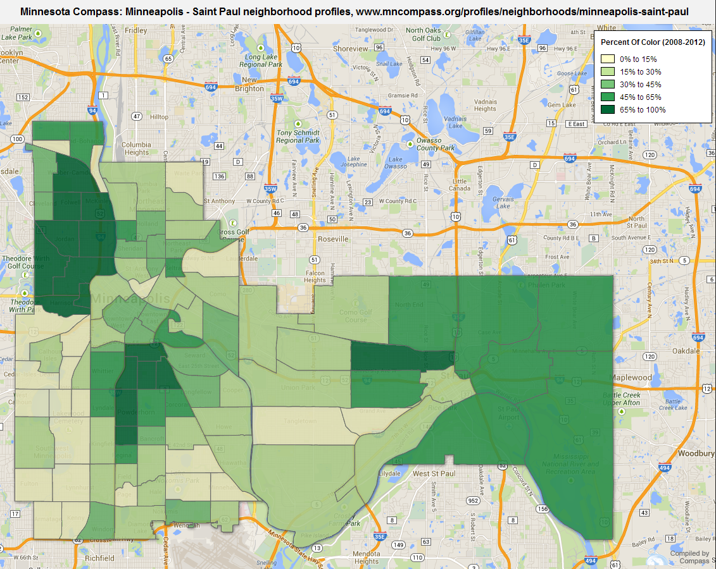
Data source: Minnesota Compass - The data come from the U.S. Census Bureau, 2010 decennial census (demographic data including total population, race and ethnicity, as well as housing units and types of households);
Access the interactive map at: http://www.mncompass.org/profiles/neighborhoods/minneapolis-saint-paul#!percent-of-color
