Minnesota Department of Health

# Suicide Prevention Awareness Month Social Media Toolkit

September 2021

## You Matter. Talk to Us. Crisis Resources

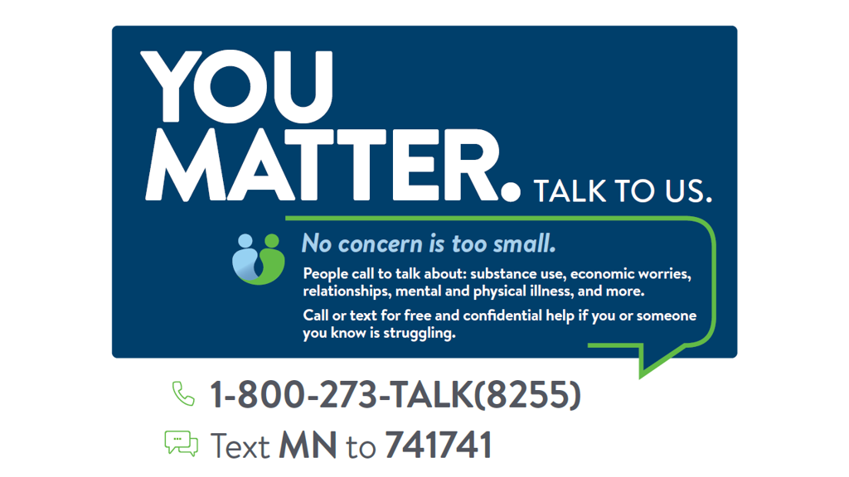

## Quick Posts

*Quick posts are short messages that can be shared on social media and/or on an employee intranet or message board. These messages are brief and to the point. Adding graphics or images can enhance your post.*

Week 1 –September 6 – 10: Promote crisis resources

**Key Messages:**

You Matter. Talk to Us. #YouMatterMN

**Supporting Messages:**

* If you, or someone you know, is at risk of suicide call the National Suicide Prevention Lifeline 1-800-273-TALK (8255), text MN to 741741 for 24/7 crisis support.
* Every county in Minnesota provides Mobile Crisis Services for both children and adults that may be experiencing suicidal feelings or mental health crisis. For more information: see the [directory for mental health crisis phone numbers (https://mn.gov/dhs/people-we-serve/adults/health-care/mental-health/resources/crisis-contacts.jsp)](https://mn.gov/dhs/people-we-serve/adults/health-care/mental-health/resources/crisis-contacts.jsp) in Minnesota by county.

**Facebook/Instagram/LinkedIn Posts:**

* Mental health crisis services are available 24/7 for everyone in Minnesota. If you believe a friend, child, parent, or anyone is thinking about suicide, there is support available to you. For immediate danger call 911. For free and confidential support call the National Suicide Prevention Lifeline (suicidepreventionlifeline.org) 1-800-273-TALK to receive prevention and crisis resources and best practices for professionals. #YouMatterMN  
  <https://suicidepreventionlifeline.org/>
* No county is too big or small to provide you with the help and support you need. Every county in Minnesota provides Mobile Crisis Services for both children and adults that may be experiencing suicidal feelings or mental health crisis. [State Mobile Crisis Services (mn.gov)](https://mn.gov/dhs/people-we-serve/people-with-disabilities/health-care/childrens-mental-health/resources/crisis-contacts.jsp) are available within each county 24 hours a day, 7 days a week. County crisis teams are available for phone support as well as face-to-face crisis help. #YouMatterMN  
  <https://mn.gov/dhs/people-we-serve/people-with-disabilities/health-care/childrens-mental-health/resources/crisis-contacts.jsp>
* If you’re in crisis, help is available and there are options to help you cope. Text MN to 741741. The Crisis Text Line provides free crisis support 24/7 for any crisis.https://mn.gov/dhs/partners-and-providers/policies-procedures/adult-mental-health/crisis-text-line/

**Twitter:**

* If you believe a friend, child, parent, or anyone is thinking about suicide, there is support available to you. Call @800273TALK at 1-800-273-TALK (8255) for free and confidential support, resources, and best practices. You Matter. Talk to Us. #YouMatterMN  
  <http://ww.suicidepreventionlifeline.org>
* Every county in Minnesota provides State Mobile Crisis Services for children and adults that may be experiencing suicidal feelings or mental health crisis. Services are available within each county 24/7 for phone and face-to-face support. #YouMatterMN  
  <https://mn.gov/dhs/people-we-serve/people-with-disabilities/health-care/childrens-mental-health/resources/crisis-contacts.jsp>
* If you’re in crisis, help is available and there are options to help you cope. Text MN to 741741. The Crisis Text Line provides free crisis support 24/7 for any crisis. #YouMatterMN  
  <https://mn.gov/dhs/partners-and-providers/policies-procedures/adult-mental-health/crisis-text-line/>

September 10: World Suicide Prevention Awareness Day

Today is World Suicide Prevention Day, an awareness day observed on the 10th of September every year.

Take a moment to connect and reach out to someone who may need help. A simple phone call, message, or hug can go a long way towards helping someone realize suicide is not the answer. Encourage understanding, changing the way we talk about suicide by promoting hope can create a more compassionate society where those in need feel more comfortable with seeking help. #YouMatterMN

[National Suicide Prevention Lifeline 1-800-273-TALK(8255)](https://suicidepreventionlifeline.org/)

[Crisis Text Line](https://mn.gov/dhs/partners-and-providers/policies-procedures/adult-mental-health/crisis-text-line/) - Text MN to 741741.

### Week 2 – September 13: Education and awareness

**Key Message:**

Everyone plays a role in preventing suicide. Educating yourself and raising awareness can help prevent it.

**Supporting Messages:**

* Suicide is the eighth leading cause of death in Minnesota and tenth nationally. In 2019, 830 Minnesotans died by suicide. Together we can raise awareness, and build education and support.
* How we talk about suicide can help prevent suicide, and also shape the way we think and feel about the issue of suicide. Learn how to talk about suicide in a way that respects victims and survivors, and supports prevention efforts. - [suicide messaging (https://www.health.state.mn.us/communities/suicide/documents/suicidemessaging.pdf)](https://www.health.state.mn.us/communities/suicide/documents/suicidemessaging.pdf)
* You can help prevent suicide by knowing the warning signs. [Everyone Plays a Role in Suicide Prevention - Minnesota Department of Health (https://www.health.state.mn.us/communities/suicide/basics/index.html)](https://www.health.state.mn.us/communities/suicide/basics/index.html)
* There is hope. Suicide is preventable, recovery is possible, and help is available.

**Facebook/Instagram/LinkedIn Posts:**

* Suicide is the eighth leading cause of death in Minnesota and tenth nationally. In 2019, 830 Minnesotans died by suicide. Together we can raise awareness, and build education and support. Suicide is complex and there is no single cause. Certain factors can increase the risk, such as mental illness, substance use, painful losses, exposure to violence, and social isolation. You can help prevent suicide by knowing the warning signs. Keep in mind, Everyone Plays a Role in Suicide Prevention. You Matter. We all play a role in suicide prevention. #YouMatterMN  
  <https://www.health.state.mn.us/communities/suicide/basics/index.html>
* How we talk about suicide can help prevent suicide, and also shape the way we think and feel about the issue of suicide. Learn how to talk about suicide in a way that respects victims and survivors, and supports prevention efforts by reviewing suicide messaging. You Matter. We all play a role in suicide prevention. #YouMatterMN  
  <https://www.health.state.mn.us/communities/suicide/documents/suicidemessaging.pdf>
* Suicide is preventable, recovery is possible, and help is available. If you are concerned someone is at risk for suicide stay with the person, ask them about it directly. Research shows this will not put an idea in their head, but might help save a life. Call the National Suicide Prevention Lifeline 1-800-273-TALK for support and guidance, or seek help from a medical or mental health professional.https://suicidepreventionlifeline.org/

**Twitter:**

* Suicide is the 8th leading cause of death in Minnesota and 10th nationally. In 2019, 830 Minnesotans died by suicide. Prevent suicide by knowing the warning signs. Keep in mind, [Everyone Plays a Role in Suicide Prevention](https://www.health.state.mn.us/communities/suicide/basics/index.html). #YouMatterMN <https://www.health.state.mn.us/communities/suicide/basics/index.html>
* Words have power! How we talk about suicide can help prevent suicide. Learn how to talk about suicide in a respectful way by reviewing suicide messaging. We all play a role in suicide prevention. #YouMatterMN <https://www.health.state.mn.us/communities/suicide/documents/suicidemessaging.pdf>
* Suicide is preventable, recovery is possible, and help is available. If you believe someone is at risk for suicide, call @800273TALK 1-800-273-TALK (8255) for support or seek help from a medical professional. #YouMatterMN   
  <https://suicidepreventionlifeline.org/>

### Week 3 – September 20 – 24: Know the impact

**Key Message:**

Sharing how much suicide impacts Minnesota communities can help us prevent it. Together, we can continue to decrease suicides in Minnesota.

**Supporting Messages:**

* Suicide is the eighth leading cause of death in Minnesota and tenth nationally. Based on preliminary data, 723 Minnesota residents died by suicide in 2020, which is lower than the 830 suicide deaths recorded in 2019.
* If you are worried that a loved one or someone you know is thinking about suicide, ask the question: “Are you having thoughts of suicide?” For tips on having that conversation: [How to Ask Someone About Suicide (https://www.nami.org/Blogs/NAMI-Blog/September-2019/How-to-Ask-Someone-About-Suicide)](https://www.nami.org/Blogs/NAMI-Blog/September-2019/How-to-Ask-Someone-About-Suicide)
* Safety plans include a personalized written list of coping strategies and sources of support if someone is in mental health distress. Anyone can experience a mental health crisis and having a safety plan can help reduce suicidal thoughts and help a person cope and find support. <https://www.sprc.org/sites/default/files/resource-program/Brown_StanleySafetyPlanTemplate.pdf>

**Facebook/Instagram/LinkedIn Posts:**

* If you are worried that a loved one or someone you know is thinking about suicide, ask the question: “Are you having thoughts of suicide?” Get more tips on how to have a conversation about suicide. #YouMatterMN   
  <https://www.nami.org/Blogs/NAMI-Blog/September-2019/How-to-Ask-Someone-About-Suicide>
* A safety plan is a written list of coping strategies and resources to support someone who might need extra mental health support, or might be at high risk of suicide. Having a safety plan can provide life-saving guidance in a crisis. Check out these tips to build your own safety plan. #YouMatterMN <https://www.sprc.org/sites/default/files/resource-program/Brown_StanleySafetyPlanTemplate.pdf>

**Twitter:**

* If you are worried that a loved one or someone you know is thinking about suicide, ask the question: “Are you having thoughts of suicide?”@NAMICommunicate provides additional tips on having a conversation:  
  <https://www.nami.org/Blogs/NAMI-Blog/September-2019/How-to-Ask-Someone-About-Suicide> #YouMatterMN
* A safety plan including coping strategies and resources can provide life-saving guidance in a mental health crisis. Check out these tips to build your own safety plan. #YouMatterMN <https://www.sprc.org/sites/default/files/resource-program/Brown_StanleySafetyPlanTemplate.pdf>

### Week 4 – September 27 – October 1: Talk about mental health

**Key Message:**

We all have mental health. Talking about it can help.

**Supporting Messages:**

* Life can be stressful. Wellness plans can help navigate the ups and downs of our own mental health and well-being. To get started: [Optum_Wellness_Wheel_Activity_Goals.pdf (https://www.mcohio.org/departments/human_resources/mcbenefits/docs/Optum_Wellness_Wheel_Activity_Goals.pdf)](https://www.mcohio.org/departments/human_resources/mcbenefits/docs/Optum_Wellness_Wheel_Activity_Goals.pdf)
* The COVID-19 Pandemic has had a major effect on our lives. Find the support you need to help you cope.
* Stay connected. Check in with people and let them know you are thinking about them. Letting a person know: "I hope you’re OK and I’m here. I’m thinking about you” can help people stay connected.

**Facebook/Instagram/LinkedIn Posts:**

* Wellness plans can help navigate the ups and downs of our own mental health and well-being. Use the template here, or create your own. #YouMatterMN  
  <https://www.mcohio.org/departments/human_resources/mcbenefits/docs/Optum_Wellness_Wheel_Activity_Goals.pdf>
* The COVID-19 Pandemic has had a major impact on everyone’s lives. It is important to be gentle with yourself and others, and to take steps to support both your own and your family's mental well-being. Consider these tips in this resource below. #YouMatterMN <https://www.health.state.mn.us/communities/mentalhealth/support.html>
* Strong social connections can help protect us, and others, from stress. Check in with people and let them know you are thinking about them. Caring contacts are a simple but effective tool in preventing suicide. Caring contacts are messages of support to show someone that you care about their well-being. Letting a person know: "I hope you’re OK and I’m here. I’m thinking about you” can help people stay connected. #YouMatterMN  
  <https://zerosuicide.edc.org/sites/default/files/nowmmattersnow.pdf>
* Social connection is an important part of both recovery from substance use disorder and suicide prevention. Support groups (either virtual or in-person), video/phone chatting, or spending time with loved ones are all great ways to maintain connection. It’s ok to seek help if you need it. Reach out to a friend, family, neighbor or crisis line. The Fast Tracker can connect you to substance use disorder and mental health providers near you. #YouMatterMN   
  <https://fasttrackermn.org/>

**Twitter:**

* Wellness plans can help navigate the ups and downs of our own mental health and well-being. Get started with this [Optum_Wellness_Wheel_Activity_Goals.pdf (mcohio.org)](https://www.mcohio.org/departments/human_resources/mcbenefits/docs/Optum_Wellness_Wheel_Activity_Goals.pdf). #YouMatterMN
* The COVID-19 Pandemic has had a major effect on our lives. Find the support you need to help you cope. Consider these tips for Supporting Mental Well-being During COVID-19. <https://www.health.state.mn.us/communities/mentalhealth/support.html> #YouMatterMN
* Letting a person know that you hope they’re OK and that you’re thinking about them can help people stay connected. For examples of how to stay connected, visit: [nowmmattersnow.pdf (edc.org)](https://zerosuicide.edc.org/sites/default/files/nowmmattersnow.pdf). #YouMatterMN

Minnesota Department of Health

Suicide Prevention Unit

85 East 7th Place

PO Box 64882

Saint Paul, MN 55164-0882

651-201-5000

[health.suicideprev.MDH@state.mn.us](mailto:health.suicideprev.MDH@state.mn.us)

[www.health.state.mn.us](http://www.health.state.mn.us)

July 28, 2021

To obtain this information in a different format, call: 651-201-5400.