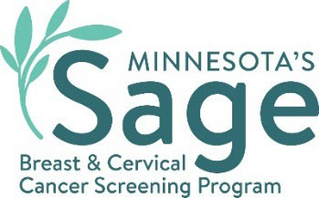

SW Minnesota Breast Cancer Campaign Social Media Content
  - hmong

Precious Moments
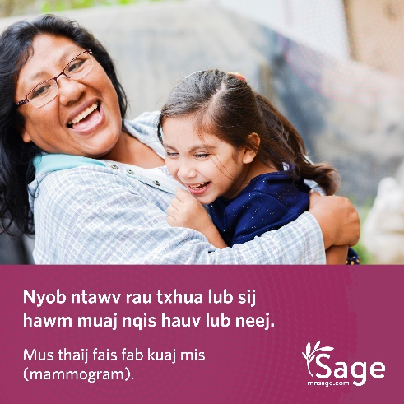
Caption: Tu koj tus kheej kom noj qab nyob zoo es nrog cov neeg uas koj hlub nyob yam mus kuaj tus kab mob cancer tas mus li. Sage, yog Minnesota txoj kev pab kuaj tus kab mob cancer, kuj yuav pab tau koj teem sij hawm thaij fais fab kuaj mis (mammogram) thiab kuaj chaw mos (Pap) thiab pab them qhov nqi kuaj koj yog hais koj tsis muaj ntawv kho mob los sis muaj ntawv kho mob tsis txaus. Hu rau Sage ntawm 1-888-643-2584. mnsage.com.
#SWSageScreening

Saves Lives

Caption: Sage, yog Minnesota kev pab kuaj tus kab mob cancer, kuj pab tau koj teem thaij fais fab kuaj mis (mammogram) thiab kuaj chaw mos (Pap) thiab pab them qhov nqi pab kuaj koj yog hais kojs tsis muaj ntawv kho mob los sis muaj ntawv kho mob tsis txaus. Hu rau Sage ntawm 1-888-643-2584. mnsage.com.
#SWSageScreening

Role Model

Caption: Qhov kev pab ntawm Sage Program no muaj thaij fais fab kuaj mis (mammograms) dawb thiab kuaj chaw mos (Pap) pub dawb rau cov neeg uas tsim nyog tau txais kev pab dawb. Hu 1-888-643-2584 kom paub seb koj puas tsim nyog tau txais kev pab thiab mus teem hnub no! mnsage.com.
#SWSageScreening

Pay Help

Caption: Sage, yog Minnesota kev pab kuaj tus kab mob cancer, koom tes nrog rau cov chaw muaj mob uas thaij fais fab kuaj mis (mammogram) thiab kuaj chaw mos (Pap) pub dawb rau cov neeg uas tsim nyog tau kev pab. Hu 1-888-643-2584 kom paub seb koj puas tsim nyog tau txais kev pab thiab mus teem hnub no! mnsage.com.
#SWSageScreening

Take Care

Caption: Sage, yog Minnesota kev pab kuaj tus kab mob cancer, xav pab kom koj thaij fais fab kuaj mis (mammogram) thiab kuaj chaw mos (Pap) pub dawb kom koj muaj kev noj qab nyob zoo. Hu 1-888-643-2584 kom paub seb koj puas tsim nyog tau txais kev pab thiab mus teem hnub no! mnsage.com.
#SWSageScreening
Minnesota Department of Health
Sage Program
625 Robert St. N
PO Box 64976
St. Paul, MN 55155-2538
888-643-2584
health.sage@state.mn.us
www.health.state.mn.us
08/07/2024
To obtain this information in a different format, call: 1-888-643-2584.

