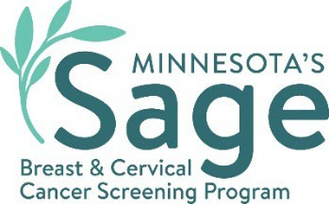

SW Minnesota Breast Cancer Campaign Social Media Content
  - somali

Precious Moments

Caption: Caafimaadkaaga ka warqab oo u joog kuwa aad jeceshahay adiga oo si joogto ah u samaynaya baaritaanada kansarka. Barnaamijka baarista kansarka Minnesota ee Sage, ayaa kaa caawin kara in aad jadwal u sameysato baaristaada raajada naasaha (Mammogram) iyo Pap test (Ilma Galeenka Haweenka) ee bilaashka ah oo ay bixiso adeegyadaas haddii aadan caymis lahayn ama hadii aad caymis leedahaba. Ka wac Sage lambarka ah 1-888-643-2584. mnsage.com.
#SWSageScreening

Saves Lives
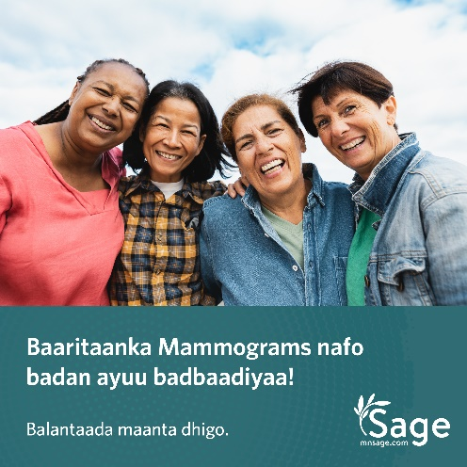
Caption: Barnaamijka baarista kansarka Minnesota ee Sage, ayaa kaa caawin kara in aad jadwal u sameysato baaristaada raajada naasaha (Mammogram) iyo Pap test (Ilma Galeenka Haweenka) ee bilaashka ah oo ay bixiso adeegyadaas haddii aadan caymis lahayn ama hadii aad caymis leedahaba. Ka wac Sage lambarka ah 1-888-643-2584. mnsage.com.
#SWSageScreening

Role Model

Caption: Barnaamijka Sage wuxuu bixiyaa baaritaanka naasaha ee mammograms iyo baaritaanka Pap test (Ilma Galeenka Haweenka) dadka u qalma.Wac 1-888-643-2584 si aad u ogaato haddii aad u qalanto oo isla maanta ballanso! mnsage.com.
#SWSageScreening

Pay Help

Caption: Barnaamijka baarista kansarka Minnesota ee Sage, wuxuu la shaqeeyaa rugaha caafimaadka si ay u bixiyaan baaritaannada naasaha ee mammograms iyo Pap test (Ilma Galeenka Haweenka) oo bilaash ah dadka u qalma. Wac 1-888-643-2584 si aad u ogaato haddii aad u qalanto oo isla maanta ka ballanso! mnsage.com.
#SWSageScreening

Take Care

Caption: Barnaamijka baarista kansarka Minnesota ee Sage, wuxuu rabaa in uu kaa caawiyo helitaanka baaritaanka naasaha ee mammogram iyo baaritaanka Pap test (Ilma Galeenka Haweenka) oo bilaash ah si aad caafimaad u qabto. Wac 1-888-643-2584 si aad u ogaato haddii aad u qalanto oo isla maanta ka ballanso! mnsage.com.
#SWSageScreening
Minnesota Department of Health
Sage Program
625 Robert St. N
PO Box 64976
St. Paul, MN 55155-2538
888-643-2584
health.sage@state.mn.us
www.health.state.mn.us
08/07/2024
To obtain this information in a different format, call: 1-888-643-2584.

