Minnesota Department of Health

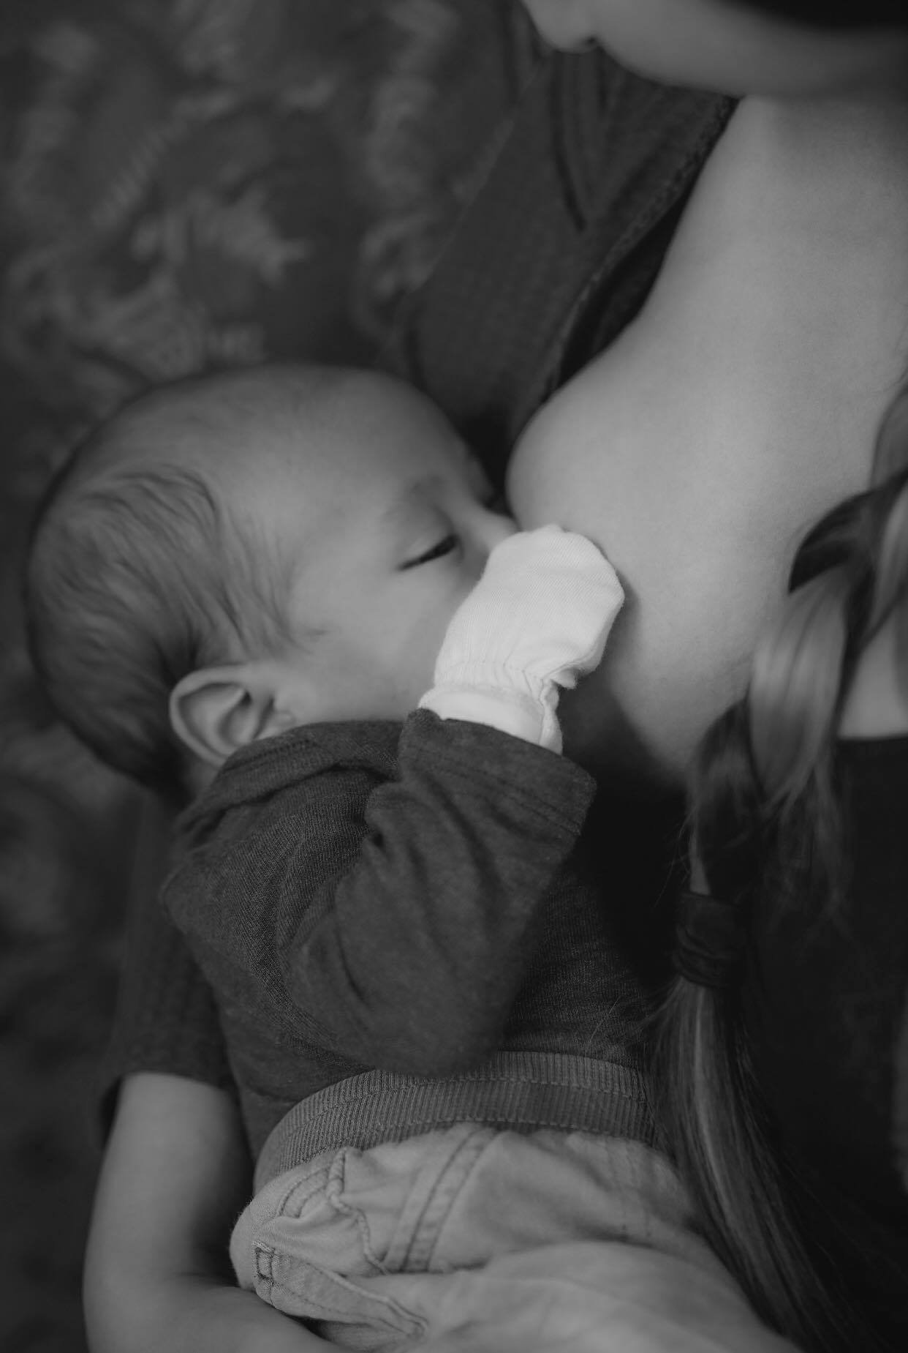

# Breastfeeding Support and Promotion – August 2023

WIC SOcial media toolkit

**For use only by WIC and Local Public Health Agencies in Minnesota**

For questions, please contact:

Minnesota Department of Health  
WIC Program  
PO Box 64882  
St. Paul, MN 55164-0882  
651-201-4404   
[health.wic@state.mn.us](mailto:health.wic@state.mn.us)  
[www.health.state.mn.us](http://www.health.state.mn.us/)

Contents

WIC Social Media Toolkit – August 1

How to Use This Toolkit 3

What is a “Social Media Toolkit?” 3

Guidance for Local Agencies 3

Responding to Comments on Your Posts 4

Social Media Ideas for August 4

Messages 5

WIC Supports Breastfeeding 5

Breastfeeding and COVID-19 6

Highlighting Cultural Communities 7

Milk Supply/Hunger and Satiety Cues 8

Laidback Breastfeeding 8

Breastfeeding Peer Program 9

Sustaining breastfeeding after returning to work 9

Information for Employers about supporting breastfeeding 10

General Breastfeeding Promotion 10

General WIC Outreach 11

Other Ideas 11

Facebook Live 12

Spotlight on WIC Breastfeeding Support Staff 12

Pictures 12

MDH WIC Photos 13

## How to Use This Toolkit

### What is a “Social Media Toolkit?”

WIC promotes and supports breastfeeding and works hard to normalize breastfeeding in the community. This toolkit was designed to make it easy for WIC local agencies to pick a message and photo to post without taking time and resources away from clinic operations. This will also help maximize WIC social media presence, sharing important information with current and potential participants. Local WIC, or local public health agencies, have the opportunity to engage with WIC participants and eligible families in a more relevant and personalized way than the Minnesota Department of Health. This toolkit provides messages and pictures to support social media efforts promoting breastfeeding. These messages are consistent with MDH’s position, and the pictures are designated for WIC and WIC partner use.

### Guidance for Local Agencies

MN WIC follows the [World Alliance for Breastfeeding Action (WABA)](https://worldbreastfeedingweek.org/) theme for World Breastfeeding Week: “Enabling Breastfeeding: Making a difference for working parents” and the [United States Breastfeeding Committee](http://www.usbreastfeeding.org/nbm) theme for National Breastfeeding Month: “This is Our Why.”

Select and post any of the content in this toolkit to your agency’s social media pages. You can also use these as a starting point to create your own posts. Consider posting twice a week to keep your followers engaged. You do not need to use all the posts.

You are encouraged to use your own pictures, as long as you have a signed release form giving your agency permission. If you don’t have your own pictures to use, you can select and use images or video links in this toolkit. Please do not edit the MDH pictures.

### Creating posts

* Keep posts short. About three sentences is a good length.
* Include a link, pointing to a website to learn more about the topic. If you’re including a link in an Instagram post, add the link to your profile and the text, “Link in profile” to your post.
* Include the “#MNWIC” hashtag and other relevant hashtags.
  + This makes our posts more visible statewide. Hashtags connect similar conversations, so they are seen by anyone searching for the hashtag.
  + Other hashtags: #WBW2023 (during World Breastfeeding Week), #BBW23 (during Black Breastfeeding Week), #NationalBreastfeedingMonth, #normalizebreastfeeding, #breastfeeding, #breastfeedingsupport, #WABA, #buildingbackbetter, , #EmpoweringParentsCampaign, #EnablingBreastfeeding, #WarmChain. You can also make your own hashtag for your agency.
* Make sure your photos are clear, well-lit, and match the post.
* Use plain language so your followers understand your message.
* You must use your agency photos in Instagram posts. This social media platform requires users to post photos they took or have the rights to post. You cannot use generic website photos or MDH photos on this social media platform.
* YouTube videos make great Facebook posts. Include a couple sentences addressing the video’s main message and add the YouTube video link. Don’t include a photo because the video preview will show in the post. Select shorter videos to hold your followers’ interest.
* You can pay to “boost” posts so they show up in more newsfeeds. Typically, a user only sees a post if they follow the page, or if one of their friends interacts with the post. Boosting a post displays the post to social media users who meet specified criteria. There are more requirements for posts you choose to boost, and your agency may need to spend time monitoring the post and responding to comments. If you have questions about boosting posts, contact Megan Leonard at [megan.leonard@state.mn.us](mailto:megan.leonard@state.mn.us).

### Responding to Comments on Your Posts

Interacting with your followers is part of the benefits of social media. Take time to answer questions and respond to comments. This will help you reach more people using your social channels.

Unfortunately, unfriendly or biased comments are a part of social media. MDH Communications suggests responding to complaints in a neutral, understanding manner. Be as open as possible and follow your agency’s or county’s social media guidelines.

You should try to respond to comments the same day they are posted. Certain comments don’t need a response, or other Facebook users may provide an adequate response for you. If you need help formulating a response to a question or comment, contact Megan Leonard at [megan.leonard@state.mn.us](mailto:megan.leonard@state.mn.us) for assistance.

### Social Media Ideas for August

MDH WIC will post consistent Facebook and Instagram posts during Breastfeeding Awareness Month. Follow [Minnesota WIC on Facebook (https://www.facebook.com/MNWIC)](https://www.facebook.com/MNWIC) and [Minnesota WIC on Instagram (https://www.instagram.com/minnesotawic/)](https://www.instagram.com/minnesotawic/) throughout August to interact with and share our posts.

Consider posting additional social media content throughout Breastfeeding Awareness Month and for each of the dedicated breastfeeding weeks. (World Breastfeeding Week, Indigenous Milk Medicine Week, Asian American Native Hawaiian and Pacific Islander Breastfeeing Week,Black Breastfeeding Week, and Lactancia Latina.) Local agencies are encouraged to share MDH WIC posts as well. This toolkit contains posts targeted to help local agencies engage and interact with current participants as well as eligible families. Here is a sample schedule for local agencies:

|  |  |  |
| --- | --- | --- |
| Approximate Post Date | Sample Post Topic | Platform(s) |
| **August 1-7** | [World Breastfeeding Week (WBW) (https://worldbreastfeedingweek.org/)](https://worldbreastfeedingweek.org/) Enabling Breastfeeding: Making a difference for working parents | **Facebook/Twitter/Instagram** |
| **August 8-14** | [Indigenous Milk Medicine Week (https://www.facebook.com/IndigenousMilkMedicineWeek/)](https://www.facebook.com/IndigenousMilkMedicineWeek/)  From the Stars to a Sustainable Future | **Facebook/Twitter/Instagram** |
| **August 15-21** | [Asian American Native Hawaiian and Pacific Islander Breastfeeding Week (https://www.facebook.com/APIBTF)](https://www.facebook.com/APIBTF) | **Facebook/Twitter/Instagram** |
| **August 25-31** | [Black Breastfeeding Week (https://www.facebook.com/BlackBreastfeedingWeek)](https://www.facebook.com/BlackBreastfeedingWeek) BBW 2023: We Outside! Celebrating Connection & Our Communities | **Facebook/Twitter/Instagram** |
| **September 5-11** | Lactancia Latina | **Facebook/Twitter/Instagram** |

## Messages

These posts are designed for Facebook, since most Minnesota local agencies use that platform. Twitter limits posts to 280 characters (links take up 23 of those characters). Instagram posts should only use original pictures taken by your local agency.

[WABA develops a social media toolkit (https://worldbreastfeedingweek.org/social-media-kit/)](https://worldbreastfeedingweek.org/social-media-kit/) for World Breastfeeding Week and has graphics and social media posts available on its website for any partner to use.

### WIC Supports Breastfeeding

* Breastfeeding is important for babies, mothers, other birthing parents, and families. Lack of support is one of the main reasons families can’t meet their goals. [Insert WIC Agency] supports families before and during their infant feeding journey. Find out how WIC can support you! [local agency website]
* [Insert WIC agency] supports breastfeeding in any amount and is here for families feeding their babies with a combination of human milk and formula and families exclusively using formula. Apply for WIC early in pregnancy and reach out to [local agency] for breastfeeding information and support.
* Breastfeeding/chestfeeding is wonderful for your baby and you! WIC is here to support you; visit [local agency]. A lactation specialist can check your baby’s latch, give tips on comfortable nursing positions, and provide other helpful resources as you breastfeed your baby. Come see us soon!
* Milk supply questions? Preparing to breastfeed/chestfeed your baby? Returning to work soon? [local agency] has lactation consultants and/or peer counselors ready to see you at our clinic and answer your breastfeeding/chestfeeding questions! Call us or come see us at your next appointment! [local agency website]
* Meet the [local agency] peers! These past WIC participants have personal breastfeeding/chestfeeding experience and are trained to support you on your journey feeding your baby. You can call or visit us at our clinic! [local agency website.]
* Human milk is a valuable source of nutrition and protection for babies. It’s vital to give breastfeeding/chestfeeding parents a strong support system. [Agency name] WIC is here to support parents and babies. [include agency website]
* [Agency name] WIC helps new parents reach their breastfeeding goals by providing healthy foods and breastfeeding information and resources. Learn more and apply online: [Women, Infants & Children (WIC) (https://www.health.state.mn.us/people/wic/)](https://www.health.state.mn.us/people/wic/)
* New parents need support and good information as they begin their breastfeeding journey. You are not alone. Find out how [agency name] WIC can support you: [agency website]
* Minnesota law says a mother may breastfeed in any location, public or private, where the mother and baby are authorized to be. Celebrate your breastfeeding journey with [agency name] WIC. [Event details if your agency is hosting an event]
* All parents with young children should have access to breastfeeding resources and support. [Agency name] WIC can help: [agency website]
* Hungry babies need to eat! Breastfeed your babies anywhere. Minnesota laws protect breastfeeding. Know your rights!
  + [Minnesota Laws Protect Breastfeeding (https://www.health.state.mn.us/docs/people/wic/localagency/bf/laws.pdf)](https://www.health.state.mn.us/docs/people/wic/localagency/bf/laws.pdf)
* Breastfeeding parents need access to healthy foods as they work hard to nourish their baby. [Agency name] WIC can help! WIC provides extra foods for breastfeeding parents.
* [WIC Fully Breastfeeding (https://www.health.state.mn.us/docs/people/wic/localagency/nutrition/fpchange/materials/pictorials/fbf.pdf)W](https://www.health.state.mn.us/docs/people/wic/localagency/nutrition/fpchange/materials/pictorials/fbf.pdf)

### Sustaining breastfeeding after returning to work

* MN strengthened its laws protecting lactation breaks as of July 1, 2023. Learn more about your updated rights, including break times regardless of your child’s age.
  + [Learn about your rights in the workplace. (https://www.dli.mn.gov/sites/default/files/pdf/DLI_WESA_Brochure_English.pdf)](https://www.dli.mn.gov/sites/default/files/pdf/DLI_WESA_Brochure_English.pdf)
  + This brochure is available in:
  + <https://www.dli.mn.gov/sites/default/files/pdf/DLI_WESA_Brochure_Spanish.pdf>
  + <https://www.dli.mn.gov/sites/default/files/pdf/DLI_WESA_Brochure_Hmong.pdf>
  + https://www.dli.mn.gov/sites/default/files/pdf/DLI_WESA_Brochure_Somali.pdf
* Did you know that you now qualify for pregnancy and parental leave regardless of the amount of time for which you’ve worked for your employer? You may take up to 12 weeks of unpaid leave during or following pregnancy, allowing you time to bond with your baby and get breast/chestfeeding off to a good start.
  + [Pregnancy and parental leave (https://www.dli.mn.gov/sites/default/files/pdf/parental_leave.pdf)](https://www.dli.mn.gov/sites/default/files/pdf/parental_leave.pdf)
* Breastfeeding after returning to work can be challenging. Here are a few [Agency name] WIC tips to help you continue your breastfeeding journey while working.
  + Find a child-care provider who is supportive of breastfeeding.
  + Breastfeed your baby right before you leave and as soon as possible once you get home.
  + Breastfeed often when you are at home.
* To the working, breastfeeding moms – what are tips that helped you continue breastfeeding your baby after going back to work?
* Trying to figure out how you’ll continue breastfeeding after returning to work? The [agency name] WIC staff can help you understand your rights so you can advocate for yourself and your baby.
* Going back to work and planning to continue breastfeeding? Planning will help make it a smoother transition for you and your baby. Here are some resources to help:
  + [Going Back to Work (https://wicbreastfeeding.fns.usda.gov/going-back-to-work)](https://wicbreastfeeding.fns.usda.gov/going-back-to-work)
* Here is the [agency name] WIC lactation room for our employees. Show us your workplace lactation room. What helped you continue breastfeeding after returning to work?

### Information for Employers about supporting breastfeeding

* Minnesota law now requires employers notify all employees of the right of pregnant and lactating employees when hired, when an employee makes an inquiry about or requests parental leave and in an employee handbook if one is provided. Here’s an example [Nursing Mothers, Lactating Employees, and Pregnancy Accomodations employee notice (https://dli.mn.gov/sites/default/files/pdf/WESA_employee_notice.pdf)](https://dli.mn.gov/sites/default/files/pdf/WESA_employee_notice.pdf)
* Employers play a huge role supporting moms’ breastfeeding goals! Here are industry-specific tips.
  + [Lactation Break Time and Space All Industries (https://www.womenshealth.gov/supporting-nursing-moms-work/lactation-break-time-and-space-all-industries)](https://www.womenshealth.gov/supporting-nursing-moms-work/lactation-break-time-and-space-all-industries)
* What do you need to make a comfortable, functional lactation room for breastfeeding moms? The basics include a private room with an outlet, a comfortable chair and side table. A sink to wash pump parts, paper towels to clean up spills, a mirror, and a fan are also helpful for pumping moms.
  + Do you own or manage a business? Here’s how you can support your breastfeeding employees who need to pump at work.
* [Employers Supporting Lactation Employees (https://youtu.be/al9EWUwLWQY)](https://youtu.be/al9EWUwLWQY)

### Highlighting Cultural Communities

* Breastfeeding rates dropped overall among WIC participants during the COVID-19 pandemic, but Hmong WIC participants have had the smallest losses during this time. Watch as mothers, partners and grandparents share their breastfeeding stories with the Hmong Breastfeeding Coalition.
  + [Hmong Breastfeeding Coalition (https://vimeo.com/showcase/7011058)](https://vimeo.com/showcase/7011058)
* “Since the dawn of time, Black mothers shared their magic with their babies through liquid gold: their breastmilk."

That’s an excerpt from one of two beautiful stories African American community members collaborated to create. “Liquid Gold” and “It Takes a Village” are meant to uplift and empower Black women to breastfeed their babies. Download and read the books:

* + [Strong Black Babies (https://www.strongblackbabies.org/)](https://www.strongblackbabies.org/)
* Considering breastfeeding and need inspiration or moral support? Watch as mothers and health care providers in the African American community share their breastfeeding journeys.
  + [Chocolate Milk (http://www.chocolatemilkdoc.com/series)](http://www.chocolatemilkdoc.com/series)
* Breastfeeding initiation rates among Black WIC Families dropped in the last two years. If you need resources or encouragement, reach out to [agency name] WIC for help. The Minnesota Breastfeeding Coalition also has resources for the African American community:
  + Minnesota Breastfeeding Coalition African American Community (https://www.mnbreastfeedingcoalition.org/african-american-community)
* “Breastfeeding is the first preventative act we can do for our babies and mothers.” Watch the National First Food Racial Equity Cohort address removing barriers to breastfeeding for women of color.
  + [First Food Cohort (https://youtu.be/sNWCND-q7jE)](https://youtu.be/sNWCND-q7jE)
* Breastfeeding parents need a strong support system and encouragement. There are local groups that can help Indigenous WIC families:
  + [Indigenous Perinatal and Lactation Support Circle - Nitamising Gimashkikinaan (https://www.facebook.com/groups/nitamising.gimashkikinaan)](https://www.facebook.com/groups/nitamising.gimashkikinaan)
  + [Mewinzha Ondaadiziike Wiigaming (https://www.facebook.com/Mewinzha)](https://www.facebook.com/Mewinzha)
* [Agency name] WIC has peer breastfeeding counselors who are ready to connect with you and provide information and support as you breastfeed your baby. WIC recruits peer counselors from the communities they serve.
  + [Breastfeeding & You - MN WIC Program (https://www.health.state.mn.us/people/wic/bf/index.html)](https://www.health.state.mn.us/people/wic/bf/index.html)

### Milk Supply/Hunger and Satiety Cues

* Do you have questions about your milk supply? [Agency name] WIC breastfeeding support staff can give you tips to know that your baby is getting enough milk!
* Babies’ tummies are tiny! Did you know that a newborn’s stomach is only about the size of a grape? [Agency name] WIC has resources to help breastfeeding moms know when their baby is full. This information can help moms successfully meet their breastfeeding goals.
* Is your baby drinking more than you’re pumping when you’re away? Make sure your baby’s care providers are practicing paced bottle feeding, so your baby is drinking exactly how much they need. This video can help start the conversation.
  + [Paced Bottle Feeding (https://www.youtube.com/watch?v=OGPm5SpLxXY)](https://www.youtube.com/watch?v=OGPm5SpLxXY)
* Am I making enough milk? Is my baby breastfeeding long enough? How can I increase my supply? These are questions most breastfeeding parents ask themselves. We’re here to help. Find more tips here or contact [agency name] WIC:
  + [Increasing Your Milk Supply (https://wicbreastfeeding.fns.usda.gov/low-milk-supply)](https://wicbreastfeeding.fns.usda.gov/low-milk-supply)
* They may be as subtle a gentle nudge with their hand or as obvious as a loud cry, but your baby uses cues while feeding. [Agency name] WIC can help you identify those cues and give you peace of mind knowing when your baby is getting enough breast milk.:
  + Baby Behavior Video: [Is my baby full? (https://www.youtube.com/watch?v=1ALUXZf8q3o&list=PLuBcbwDEv8PyrLucsc1UO6Xud0Buvr6rl&index=2)](https://www.youtube.com/watch?v=1ALUXZf8q3o&list=PLuBcbwDEv8PyrLucsc1UO6Xud0Buvr6rl&index=2)

### Laidback Breastfeeding

* Does your baby need a better latch? Are you uncomfortable while breastfeeding? Trying different positions can make a huge difference when feeding your baby. Laidback breastfeeding is a natural way to help your baby get a good latch and prevent sore breasts. Watch to learn some tips:
  + - [Introduction to Laid Back Breastfeeding (Biological Nurturing) (https://www.youtube.com/watch?v=PKoEnqrSkvs&t=87s)](https://www.youtube.com/watch?v=PKoEnqrSkvs&t=87s)

### Breastfeeding Peer Program

* Looking for support or help with breastfeeding? Our #MNWIC Breastfeeding Peer Counselors are here for you. Find a program near you:
  + [Map of Peer Programs (http://www.health.state.mn.us/people/wic/bf/peermap.html)](http://www.health.state.mn.us/people/wic/bf/peermap.html)
* [Agency name] WIC peer breastfeeding counselors are parents with personal breastfeeding experience who can share valuable advice. Their goal is to help you reach your personal breastfeeding goals.
  + [Breastfeeding & You - MN WIC Program (https://www.health.state.mn.us/people/wic/bf/index.html)](https://www.health.state.mn.us/people/wic/bf/index.html)
* Meet our peer breastfeeding counselors! Promoting and supporting breastfeeding is a #MNWIC priority and peer breastfeeding counselors play a key role. Learn more:
  + [Breastfeeding & You - MN WIC Program (https://www.health.state.mn.us/people/wic/bf/index.html)](https://www.health.state.mn.us/people/wic/bf/index.html)
* The #MNWIC Peer Breastfeeding Support Program expanded this year and can help 15 percent more families statewide. The expansion allows existing agency peer programs to serve a higher percentage of families. Find a peer program:
  + [Map of Peer Programs (http://www.health.state.mn.us/people/wic/bf/peermap.html)](http://www.health.state.mn.us/people/wic/bf/peermap.html)

### General Breastfeeding Promotion

* Breastfeeding is healthy for babies, good for moms and helps families. Find more information on the importance of breastfeeding.
  + [Why Breastfeed? (https://www.health.state.mn.us/people/breastfeeding/whybf.html)](https://www.health.state.mn.us/people/breastfeeding/whybf.html)
* Pregnant? Find MDH Recognized Breastfeeding Friendly hospitals, child care centers, and other facilities near [insert city/county] to start your breastfeeding journey off with resources and support!
  + [Breastfeeding Friendly Recognition Program (https://www.health.state.mn.us/people/breastfeeding/recognition/index.html)](https://www.health.state.mn.us/people/breastfeeding/recognition/index.html)
* Breastfeeding is environmentally friendly! No washing bottles, no packaging, no waste; just you and your baby. Learn more about the benefits of breastfeeding.
  + [Why Breastfeed? (https://www.health.state.mn.us/people/breastfeeding/whybf.html)](https://www.health.state.mn.us/people/breastfeeding/whybf.html)
* Why breastfeed? Breast milk changes to meet your baby’s needs. That means breastfed babies visit the physician less often, are less likely to be hospitalized, and need fewer prescriptions than formula-fed infants.
  + [Breastmilk vs. Formula (https://youtu.be/BxUpuvilLmg)](https://youtu.be/BxUpuvilLmg)
* Did you know mothers who breastfeed have less risk of breast cancer, ovarian cancer, diabetes, and heart disease? Learn more about breastfeeding benefits.
  + [Why Breastfeed? (https://www.health.state.mn.us/people/breastfeeding/whybf.html)](https://www.health.state.mn.us/people/breastfeeding/whybf.html)

### General WIC Outreach

* Women who come to WIC at least three months prior to baby’s birth have greater success with breastfeeding. Contact [local agency] WIC today for more information or to make an appointment. [include agency contact information or contact web page]
  + [How Minnesota WIC Works (https://youtu.be/H1uS7sj5RYY)](https://youtu.be/H1uS7sj5RYY)
* COVID-19 changed the way we provide services, but [local agency] WIC continues to service participants. That includes breastfeeding support! Call [insert local agency phone number] to learn about how we can help.
  + - [Welcome to Minnesota WIC (https://youtu.be/T3H4WLTZJmk)](https://youtu.be/T3H4WLTZJmk)
    - [Bienvenidos al WIC de Minnesota (https://youtu.be/9s-0EpGcWKM)](https://youtu.be/9s-0EpGcWKM)
* Here are additional MDH WIC PSAs to use with posts:
  + - [Common Questions About WIC (https://youtu.be/k7qW-LvCGnQ)](https://youtu.be/k7qW-LvCGnQ)
    - [How Minnesota WIC Works (https://youtu.be/H1uS7sj5RYY)](https://youtu.be/H1uS7sj5RYY)
    - [Signing Up for Minnesota WIC (https://youtu.be/EiHANGPMtnE)](https://youtu.be/EiHANGPMtnE)

## Other Ideas

If you want to go above and beyond a traditional post, here are some more advanced ideas for social media posts. Some of these options require a little more time but boost engagement.

### Facebook Live

* Interview a mom on Facebook Live about her experience breastfeeding after returning to work.
* Possible Questions:
  + How old is baby? How long did she breastfeed?
  + How/why did she decide she wanted to breastfeed?
  + How did she make breastfeeding work for her after returning to work?
  + What were some challenges? How did she adapt to them?
  + What does she wish she knew before she started breastfeeding? What advice does she want to share with other moms?
* The goal of this post is to help moms understand that breastfeeding is possible after returning to work and give helpful advice. Keep it positive! Avoid focusing on the negatives of a particular employer or other breastfeeding or pumping struggles. Instead, focus on how the mom overcame the challenges.

### Spotlight on WIC Breastfeeding Support Staff

* Provide a quick bio (with photo) of one of the staff in your agency to talk about the work she does and how she helps families in your area.
* Possible topics:
  + Give some background about how she came to work for WIC.
  + If applicable, she can share her experience with breastfeeding.
  + Share information about why she values WIC and how WIC helps women breastfeed and raise healthy families.

## Pictures

These photos are available for the Minnesota WIC program and its local agencies to use. Email [health.wic@state.mn.us](mailto:health.wic@state.mn.us) if you have questions regarding photo usage outside of your local agency.

### Using the photos

* Right click the photo you want to use and select “save as.”
* Save the photo to your desktop or other location.
* When you open the saved photo it will display in its original size and quality. Do not alter the pictures. Do not use these photos for Instagram posts.

### MDH WIC Photos

#### Parents and Babies

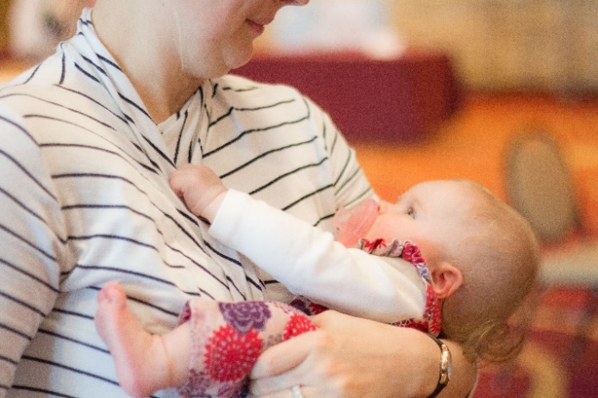 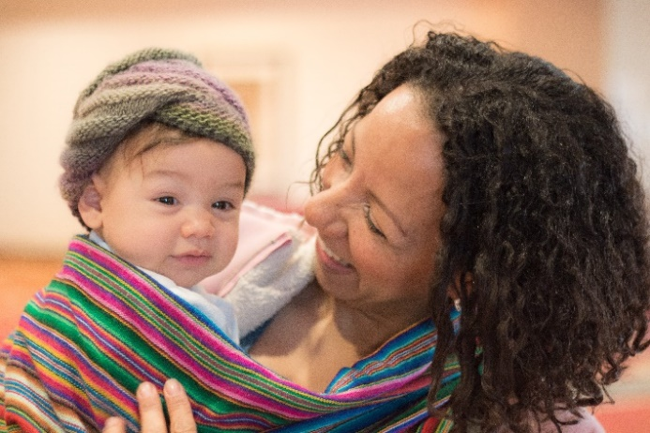

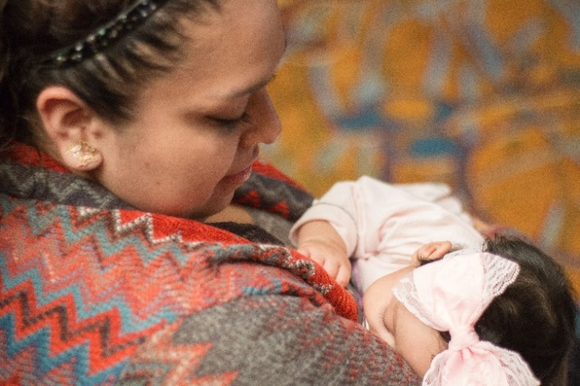 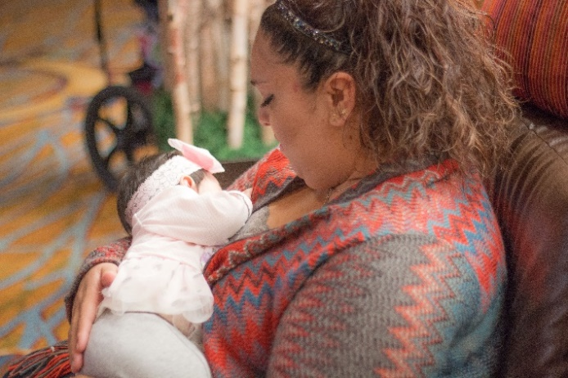

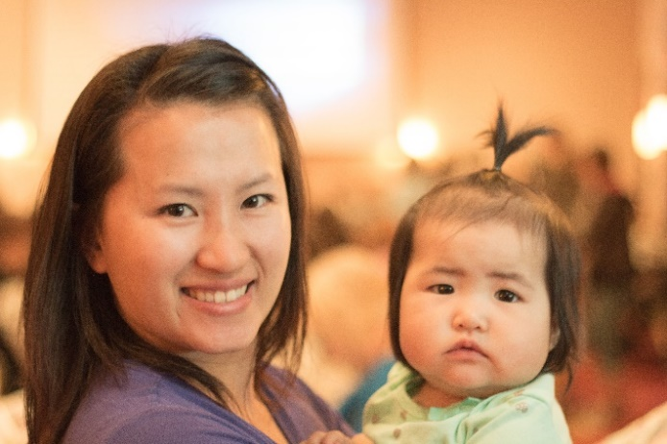 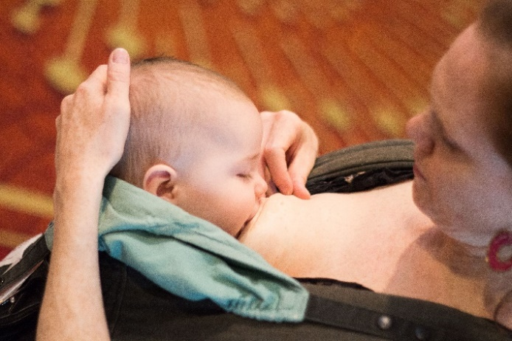

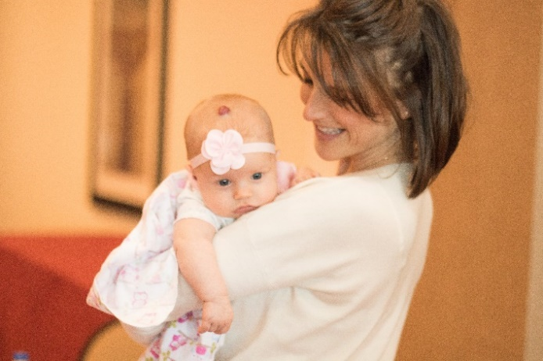 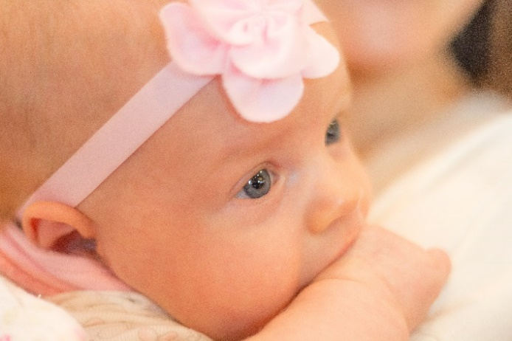

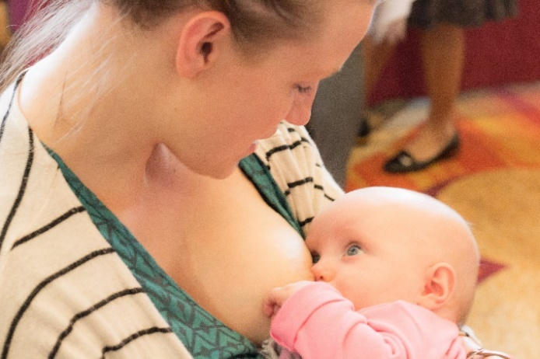 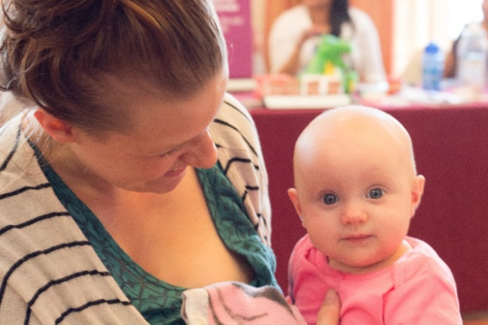

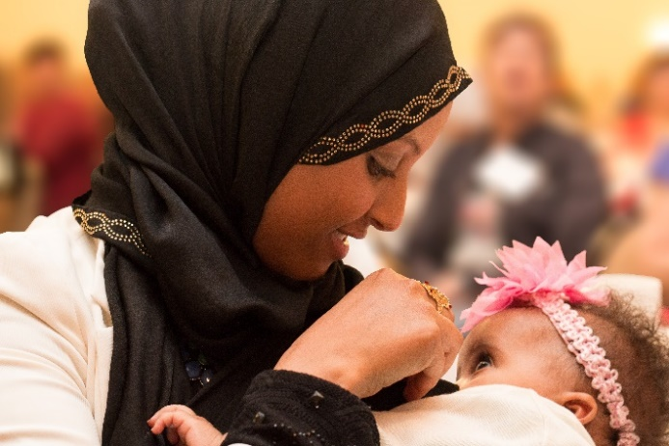 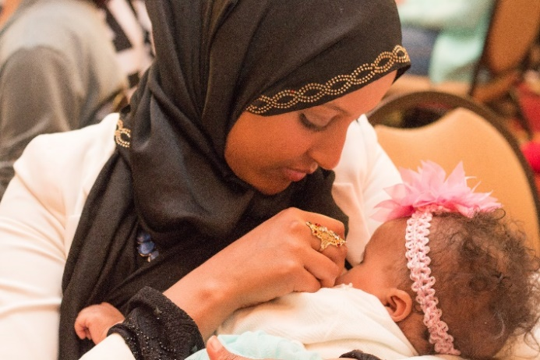

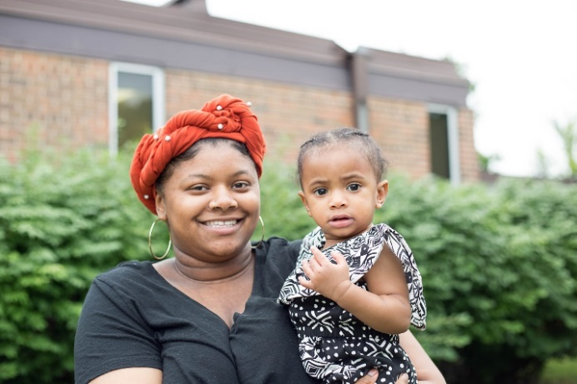 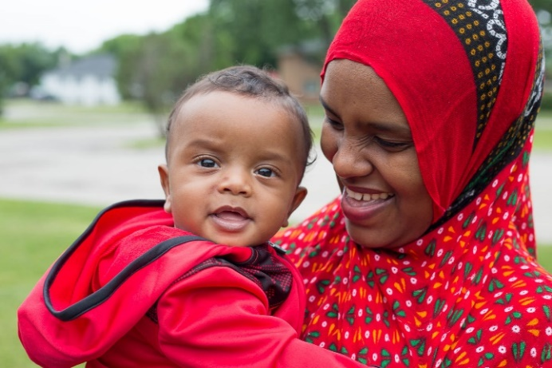

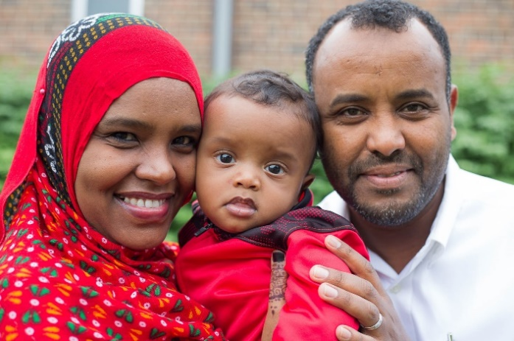 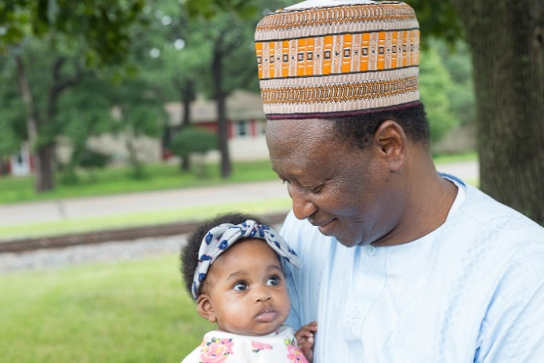

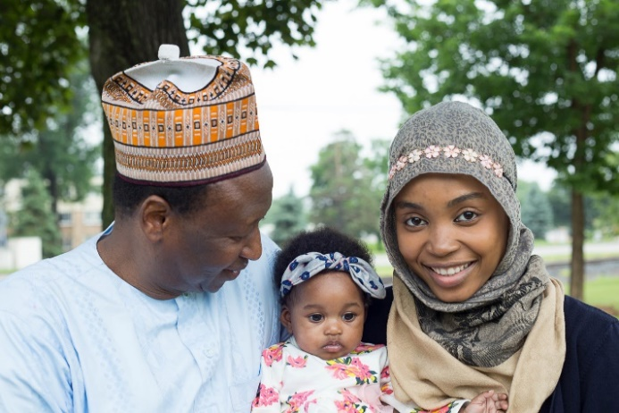 

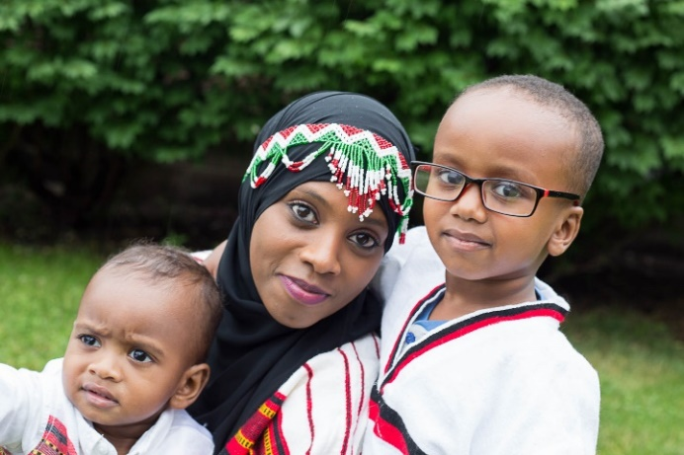 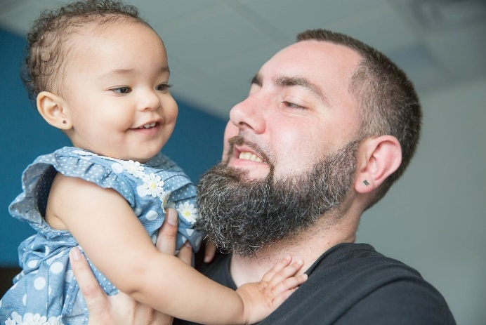

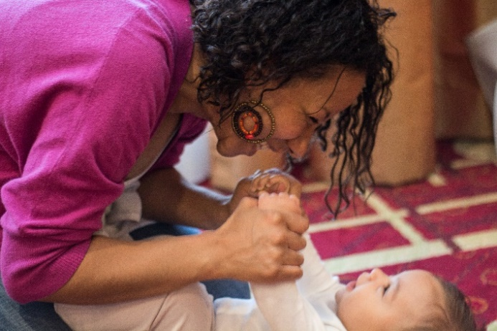

#### Babies, Children (Fully Breastfed)

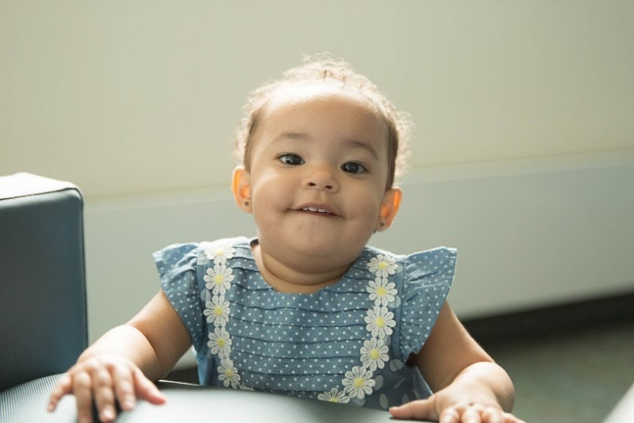 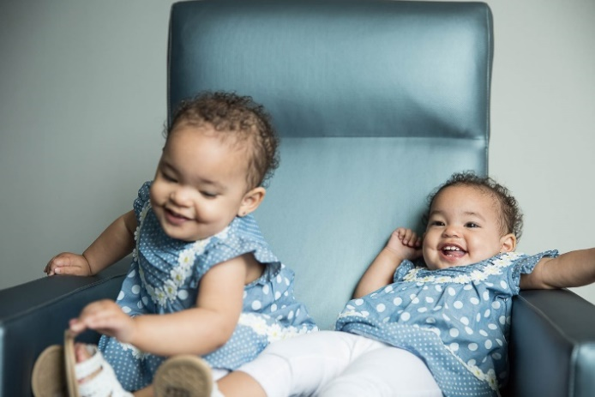

 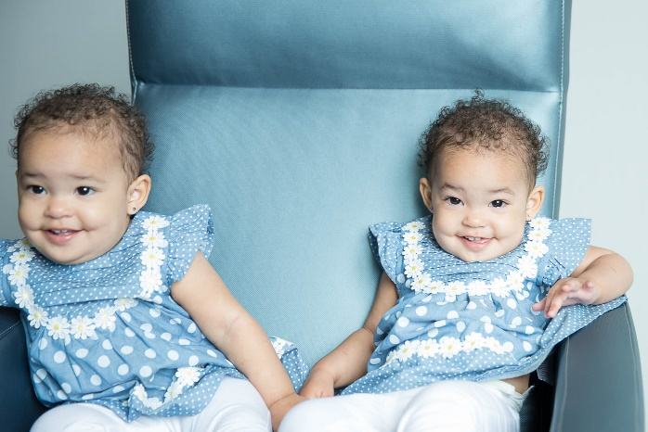

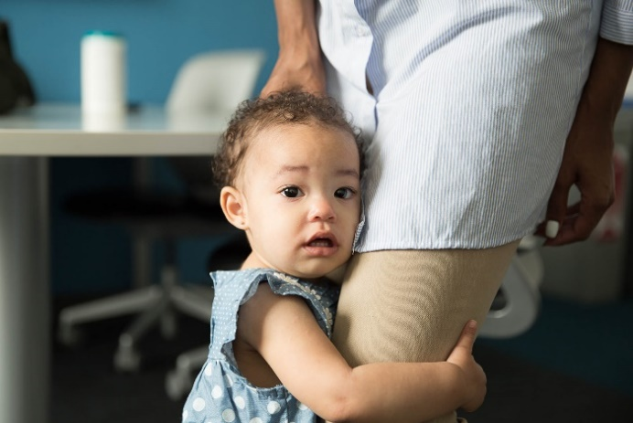 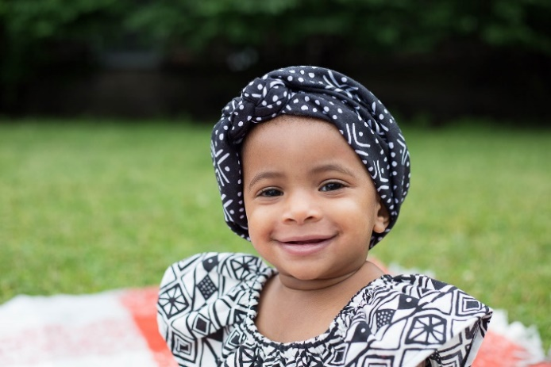

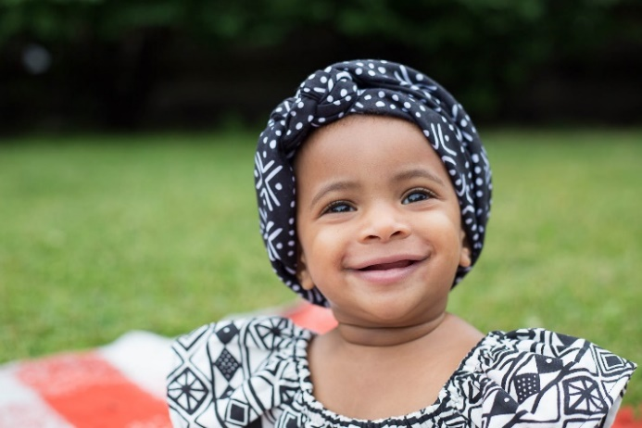 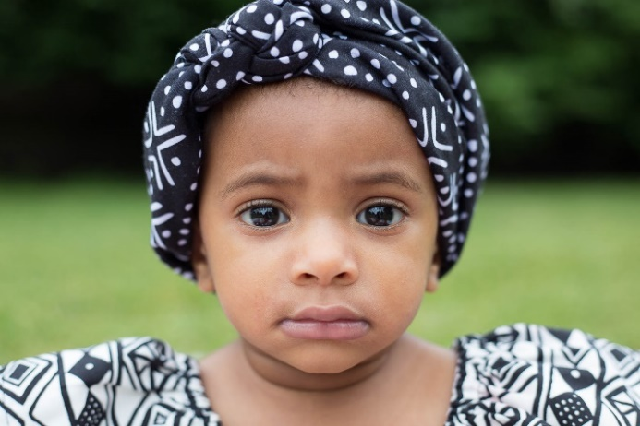

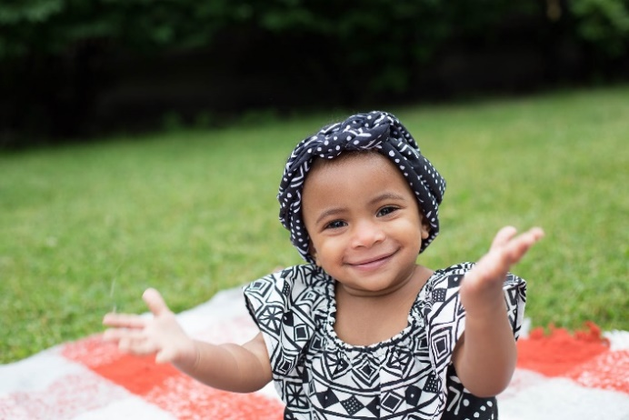 

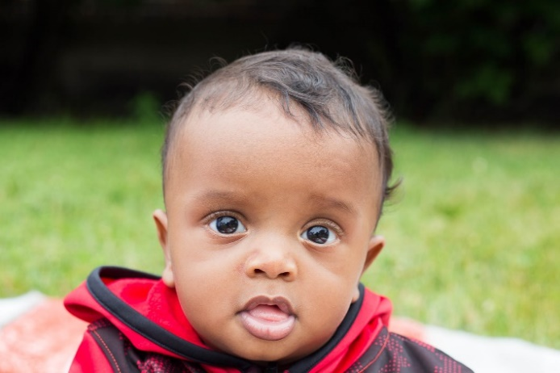 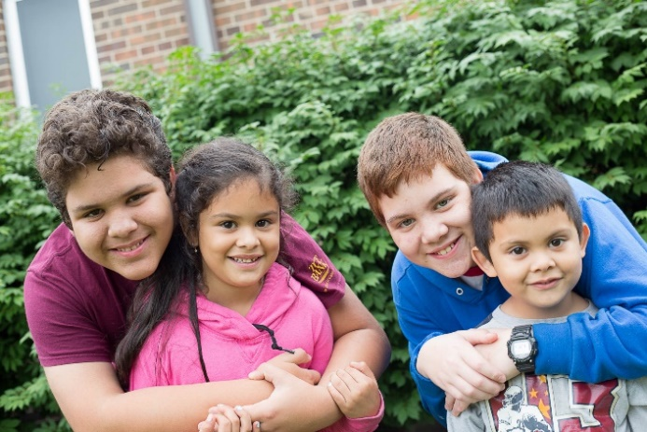

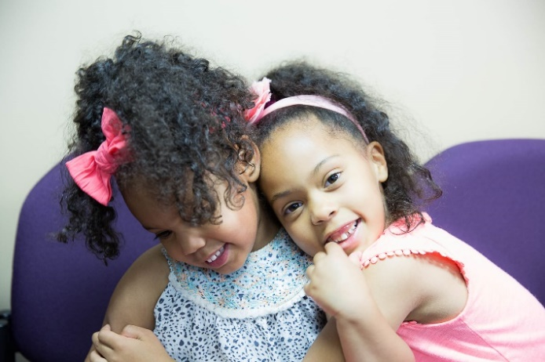 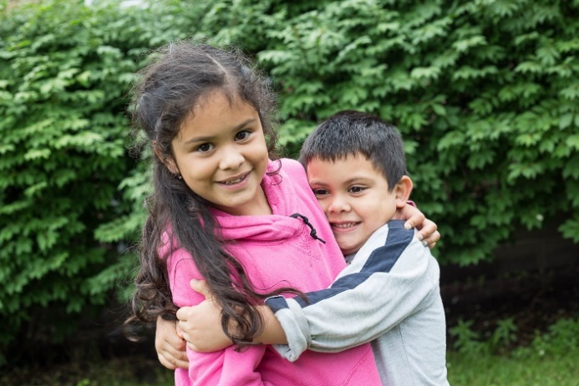

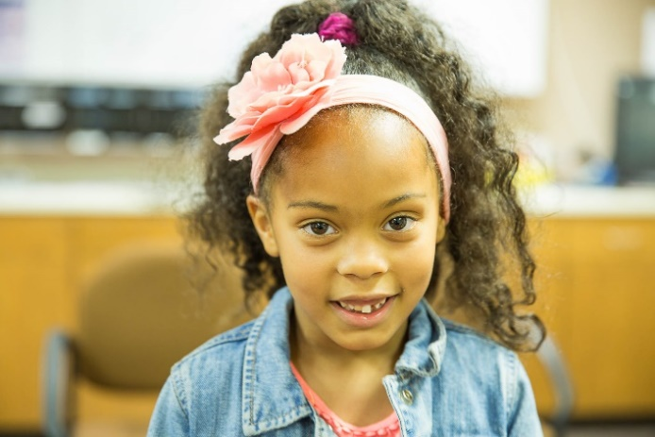 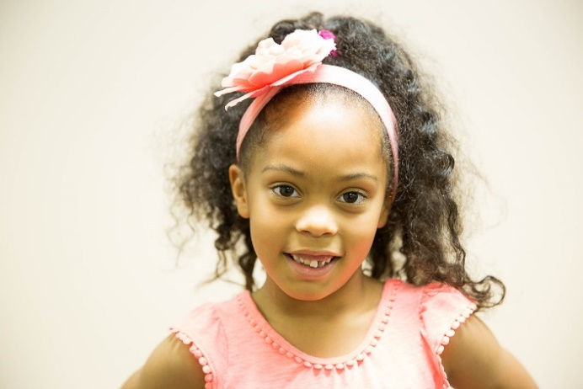

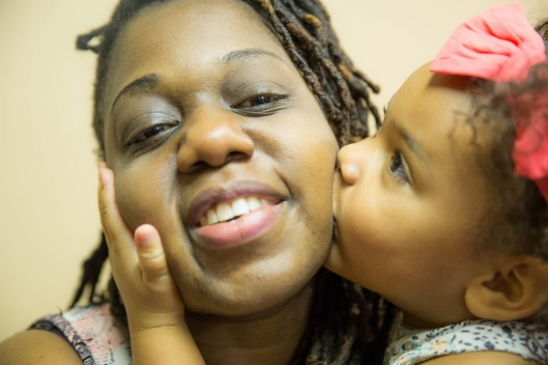 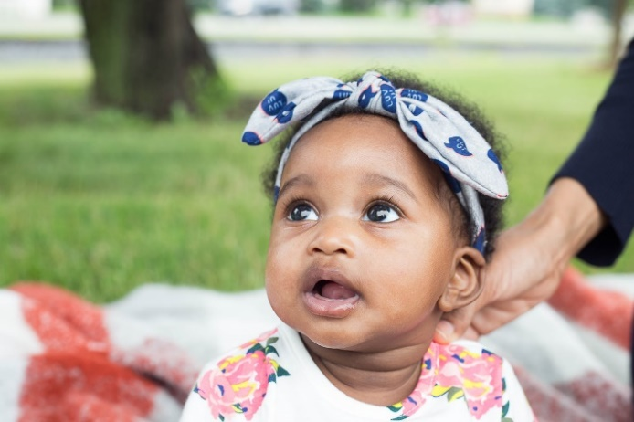

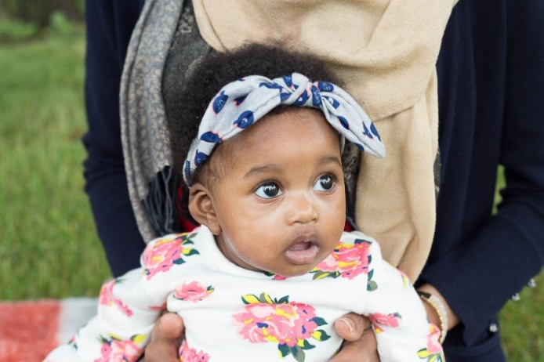 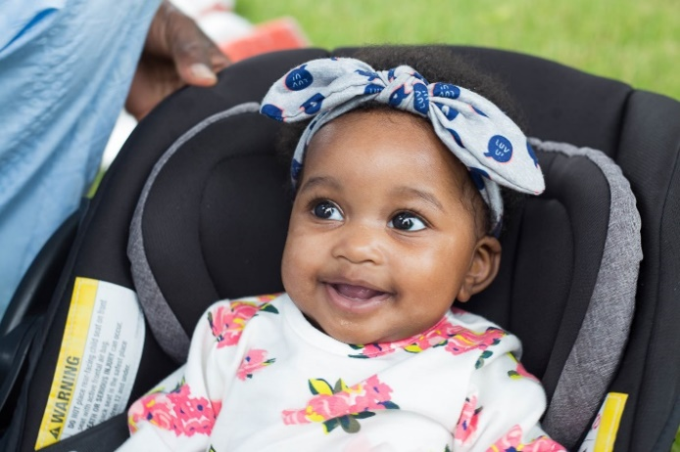

 

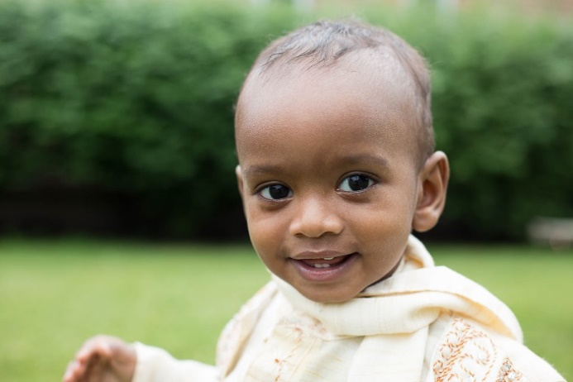 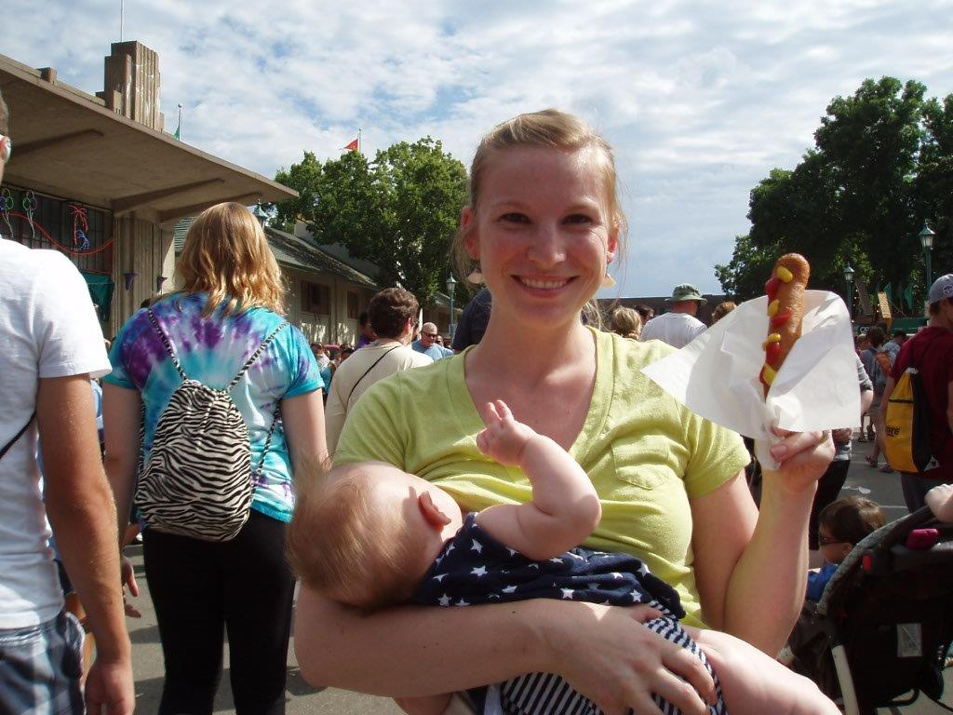

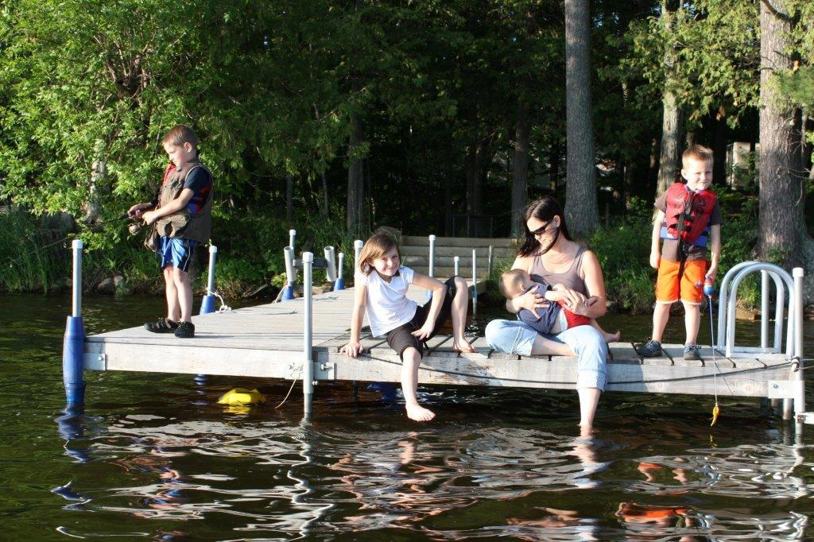 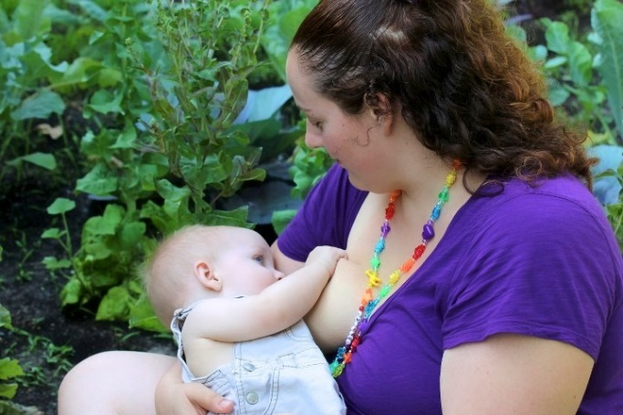

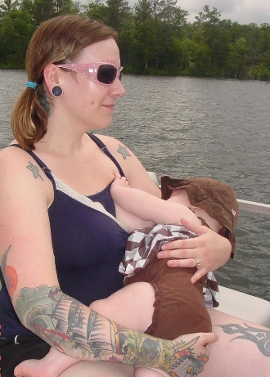 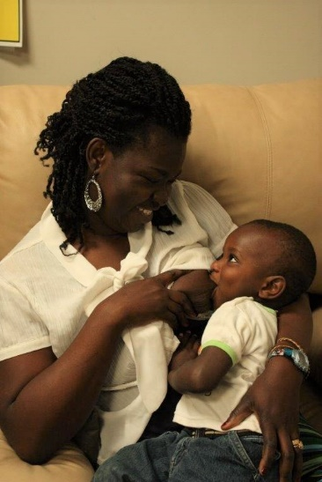 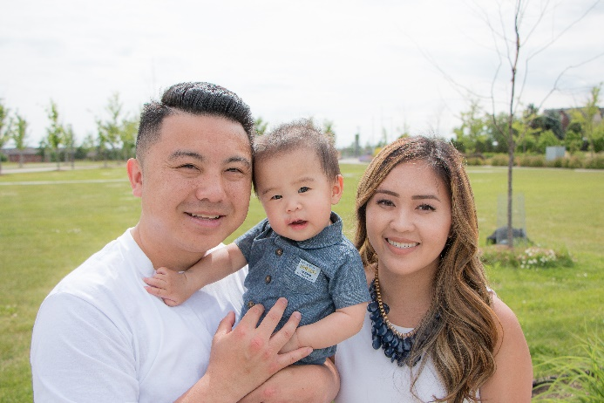

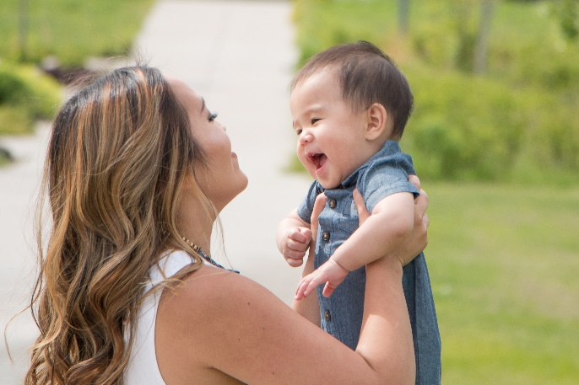 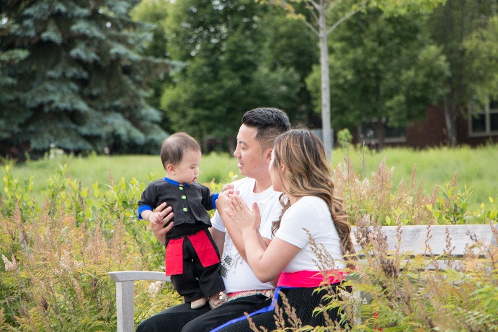

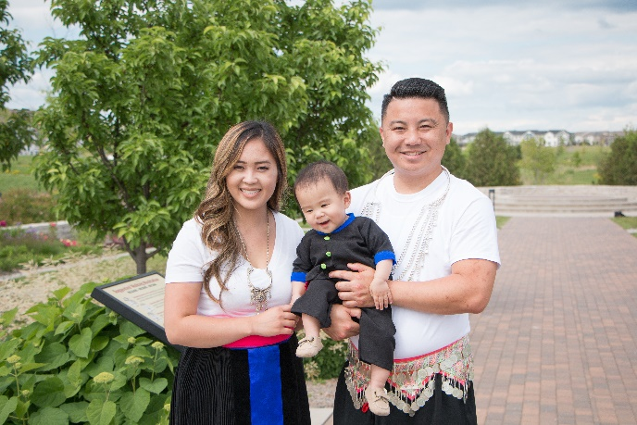

#### Lactation Rooms

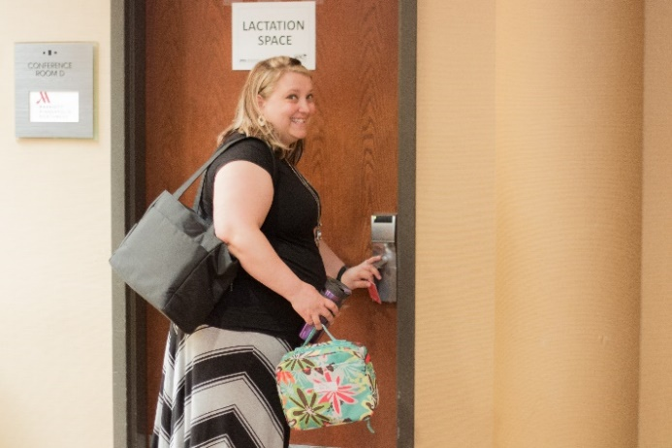 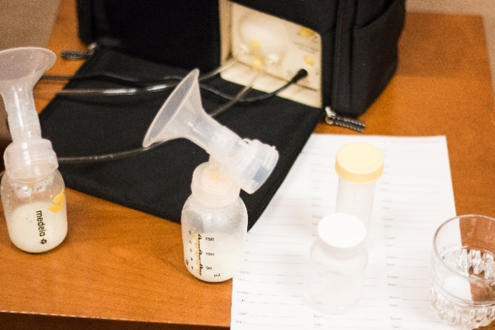

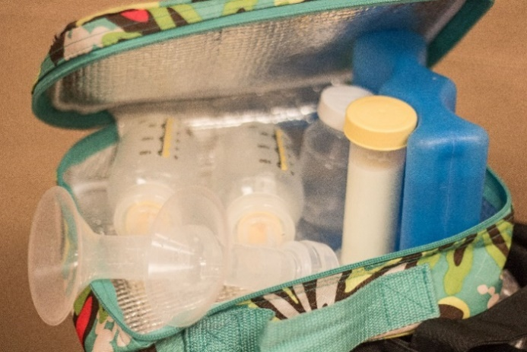 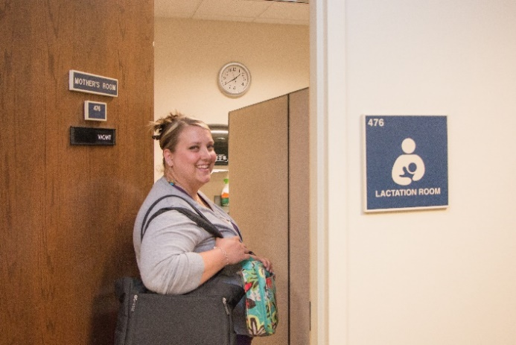

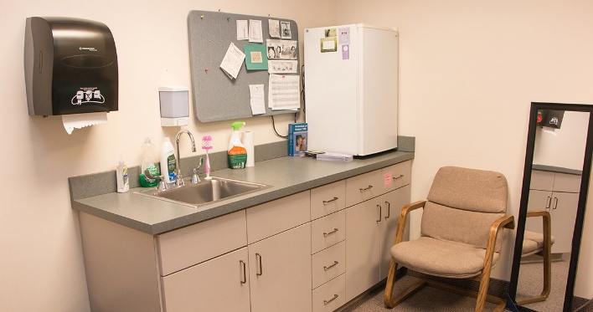

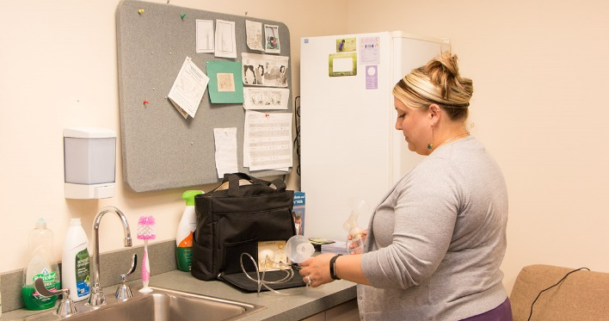

#### Peer Program

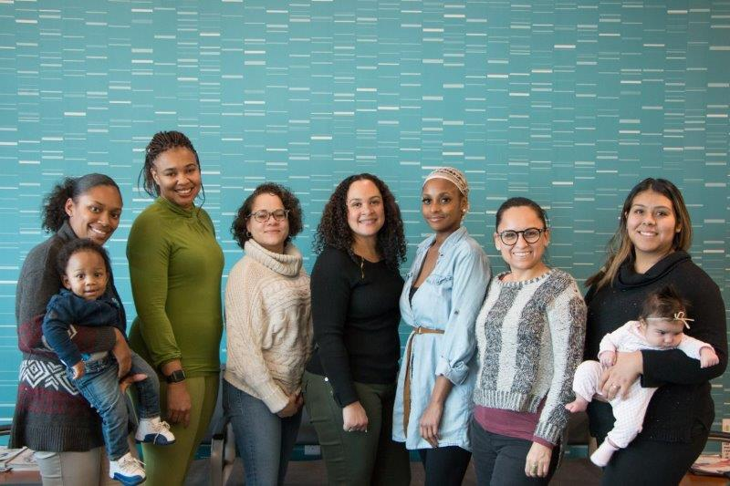 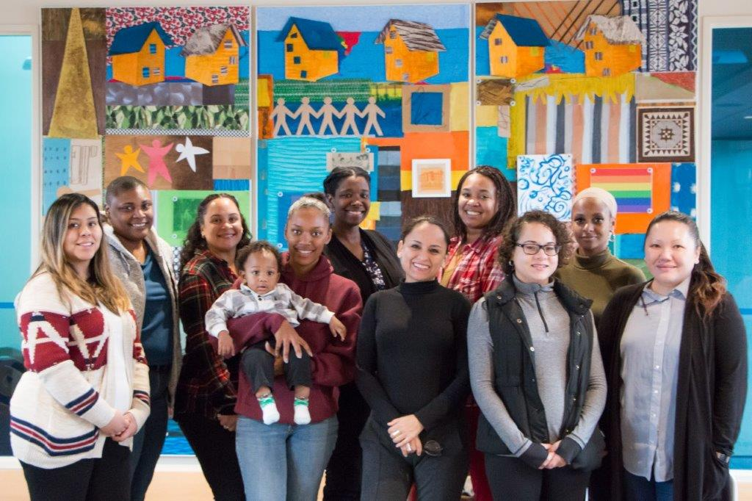

#### Babies’ Tummy Sizes

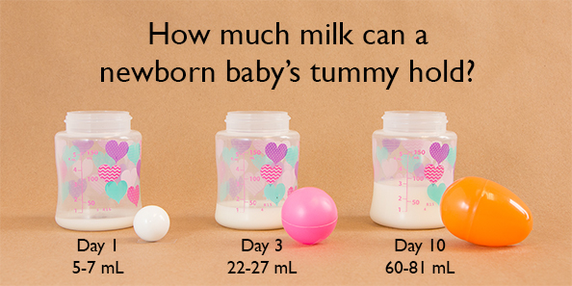

#### Other Photo Resources

There are several website recourses for free pictures.

* The [USDA WIC Image Gallery (https://wicworks.fns.usda.gov/resources/wic-image-gallery-wic-breastfeeding-support)](https://wicworks.fns.usda.gov/resources/wic-image-gallery-wic-breastfeeding-support) is one of the best resources.
* The U.S. Breastfeeding Committee provides free photos if your agency agrees to comply with their terms and conditions. These photos are located in the ["Landscape of Breastfeeding Support" Image Gallery (https://www.usbreastfeeding.org/photo-project.html)](https://www.usbreastfeeding.org/photo-project.html)
* Additional resources (some may require reviewing terms and conditions prior to using photos):
  + [PublicDomainPictures.net](http://www.publicdomainpictures.net/)
  + [Unsplash (https://unsplash.com/)](https://unsplash.com/)
  + [Free Stock Photos (http://all-free-download.com/free-photos/)](http://all-free-download.com/free-photos/)
  + [Public Health Image Library (https:/phil.cdc.gov/phil/home.asp)](https://phil.cdc.gov/phil/home.asp)