World Breastfeeding Week /National Breastfeeding Month
News Release Template 2025
  - [Date]
  - [Organization]
  - Contact: [Name]
  - [Phone], [Email]

[Headline Options – select one]
[Insert WIC Agency] Supports Breastfeeding, Chestfeeding, and Pumping to help WIC families Prioritize Breastfeeding
[Insert WIC Agency] Supports Families during National Breastfeeding Month this August and Throughout their Entire Breastfeeding Journey
[insert WIC agency] Encourages [Insert County/Local Regional Identifier] Families to Celebrate Healthy Babies and National Breastfeeding Month

Breastfeeding is important for babies, mothers, birthing parents, and families. [Local WIC Agency] supports feeding human milk to infants in any amount and provides support and resources for parents before and during their infant feeding journey.
This helps create sustainable support systems for families through:
- Talking about the importance of human milk.
- Providing extra foods to support a lactating parent’s nutrition needs.
- Providing resources to help families reach their infant feeding goals.
Breastfeeding includes any infant feeding of human milk via breast, chest, or pump.

[Content options – select one]

Option 1 (no peer program)
All families deserve breastfeeding support, so they can prioritize breastfeeding. The WIC program is dedicated to closing the gap and improving breastfeeding initiation rates for WIC participants compared to all Minnesota breastfeeding initiation rates.
“[Insert WIC agency] gives parents one-on-one support before and during their infant feeding journey,” said [Agency Spokesperson]. “We know support is key to parents starting and continuing breastfeeding their babies as they work through challenges. Our program provides nutrition support for parents and space to learn, ask questions, and celebrate success as they meet their goals.”
Learn more about WIC breastfeeding support: [link to local agency website or state website https://www.health.state.mn.us/people/wic/bf/index.html]

Option 2 (peer program)
All families deserve breastfeeding support, so they can prioritize breastfeeding. The WIC Peer Breastfeeding Support Program (https://www.health.state.mn.us/docs/people/wic/localagency/reports/bf/info/2022peer.pdf) is closing the gap. [Insert WIC agency] peer counselors are from our community and work with parents to increase breastfeeding initiation, exclusivity, and duration. In 2023 and 2024, WIC participants with a peer counselor had higher breastfeeding initiation rates compared to all Minnesota births (Breastfeeding initiation data, Minnesota WIC Program)
“[Insert WIC agency] has [number of peer counselors] who have personal breastfeeding experience and are trained to support parents,” said [Agency Spokesperson]. “We know peer counselors are making a difference in the lives of parents and babies by sharing their lived experiences and their breastfeeding knowledge. Our peer counselors, along with our other program support, are the reason more WIC participants are initiating breastfeeding and are less likely to wean at any time during a baby’s first year of life.”
Learn more about the Peer Breastfeeding Support Program [link to local agency website or state link https://www.health.state.mn.us/people/wic/bf/index.html]

Option 3 (Breastfeeding Award of Excellence recipient)
All families deserve breastfeeding support and education. [WIC agency] earned a top spot among clinics in Minnesota, and the nation, for its commitment to breastfeeding and received the [INSERT Breastfeeding Award of Excellence level].
“This award is a testament to [Insert WIC agency]’s dedication to support our families throughout their infant feeding journey. Our program staff work hard to establish a system of support for our WIC families before and during their breastfeeding journeys,” said [Agency Spokesperson]. “We know everyone’s infant feeding journey is different, and our goal is to provide tailored support to each parent to give their baby the best possible start. [Add custom information about local agency efforts.]”
The United States Department of Agriculture Food and Nutrition Service (USDA-FNS) WIC Breastfeeding Award of Excellence Program (https://www.fns.usda.gov/wic/breastfeeding-award-excellence-program) recognizes local WIC programs that provide exemplary breastfeeding promotion and support activities. [Insert local agency] efforts include:
- [example 1]
- [example 2]
- [example 3]

National Breastfeeding Month
[insert WIC agency] and the Minnesota WIC Program are celebrating National Breastfeeding Month and World Breastfeeding Week by reminding families to take advantage of the lactation education and support WIC provides for pregnant and breastfeeding parents.
Eligible families who apply for WIC (https://redcap.health.state.mn.us/redcap/surveys/?s=LNKN377EPE) early in pregnancy and ask for advice and support early and often during their infant feeding journey achieve the best possible outcomes.
[Add event information if your agency is hosting an in-person or virtual event to celebrate during August.]

- National Breastfeeding Month (https://www.usbreastfeeding.org/national-breastfeeding-month.html) (August) – Forward Together
- World Breastfeeding Week (http://worldbreastfeedingweek.org/) (Aug. 1-7) – Prioritize Breastfeeding: Creating sustainable support systems
- Indigenous Milk Medicine Week (https://linktr.ee/IndigenousMilkMedicine?fbclid=IwAR1CFQpK_9sW04UWukbczYoEogcaYYedjlQI-o6-a4wC9B9sakglbIKZW4Q) (Aug. 8-14) Mind. Body. Milk Medicine.
- Asian American Native Hawaiian and Pacific Islander Breastfeeding Week (https://www.facebook.com/APIBTF) (Aug. 15-21)
- Black Breastfeeding Week (https://blackbreastfeedingweek.org/) (Aug. 25-31) Boots on the ground: Rooted in breastfeeding success, grounded in community support
- Workplace Lactation Week (https://www.facebook.com/WorkplaceLactationWeek)(Sept. 1-7) A World of Support
- Semana de La Lactancia Latina (https://www.facebook.com/Latinxbreastfeedingweek) (Sept. 3-9)

WIC Supports Families
[Insert WIC agency] supports breastfeeding in any amount and is here for families feeding their babies with a combination of human milk and formula and families exclusively using formula.

- Apply for WIC (https://redcap.health.state.mn.us/redcap/surveys/?s=4WCPLJL77MLKRPJ3) early in pregnancy.
- Reach out to a WIC breastfeeding specialist or peer counselor at [local WIC clinic] for breastfeeding information and support. Creating a plan before birth and reaching out for help as soon as possible after birth can lead to successful breastfeeding.
- [Add information about breastfeeding classes or support groups at your agency.]
- WIC can help as parents return to work.
- WIC provides formula benefits to supplement breastfeeding when needed and can provide tips to increase milk supply for parents using a combination of human milk and formula.

Additional statistics
- The WIC Reports and Data (https://www.health.state.mn.us/people/wic/localagency/reports/index.html) webpage provides interactive breastfeeding data and trends.
- Additional information and data: Minnesota WIC Facts 2025 (PDF) (https://www.health.state.mn.us/docs/people/wic/localagency/reports/pptndemo/wicfacts/0325.pdf)

Breastfeeding initiation data, Minnesota WIC Program

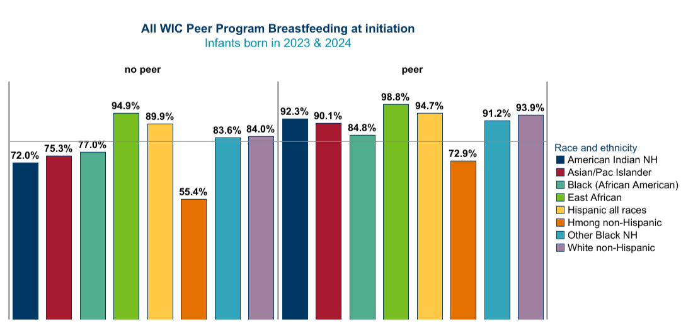
2023, 2024 breastfeeding initiation | WIC Clients no Peer | WIC Peer Clients
American Indian NH | 72.0% | 92.3%
Asian Pac Islander | 73.3% | 90.1%
Black NH | 77.0% | 84.8%
East African | 94.9% | 98.8%
Hispanic all races | 89.9% | 94.7%
Hmong | 55.4% | 72.9%
Other Black | 83.6% | 91.2%
White NH | 84.0% | 93.9%

For more information, contact [insert local WIC contact here].
###

