

WIC 50th Anniversary - Toolkit
  - October 2024
The Minnesota WIC Program is celebrating its 50th anniversary in 2024. MN WIC has a variety of messages and resources available for local WIC agencies to share in their community or use to host their own celebrations.
The WIC 50th Anniversary webpage features state and national resources to mark 50 years of WIC.

Anniversary video
MN WIC created an animated video about the WIC program and how it has evolved in the past five decades.
Minnesota WIC 50th Anniversary (YouTube)
Local agencies can post the video link to their websites, share on their social media channels, or send directly to community partners.

Partner letter template
MN WIC drafted a letter to partners for local agencies to edit and share with their community partners. This is a good opportunity to showcase the WIC program and enlist community partners’ help to encourage eligible families to apply for WIC.

Sample letter or email for partners
Use this template to email to your community partners and print on your local WIC agency letterhead and mail to partners.
Minnesota WIC partner,
Did you know the Minnesota Special Supplemental Nutrition Program for Women, Infants, and Children (WIC) is marking 50 years since the first clinic opened in Minnesota?
MN WIC helps thousands of participants access healthy food, nutrition education, and breastfeeding resources every month. The program has made significant strides in modernization over the past five decades.
The Minnesota WIC 50th Anniversary (YouTube) (https://www.youtube.com/watch?v=gC6FOEECFGo) highlights many of those changes.
[LOCAL WIC AGENCY] wants everyone who is eligible for WIC to apply.
Please help share the important work we’re doing to help families eat well and be healthy:
- Health care providers can refer families: WIC and Health Care Providers (https://www.health.state.mn.us/people/wic/hcp/index.html)
- The Welcome to WIC (https://www.health.state.mn.us/people/wic/ppthome.html) webpage offers information and a Minnesota WIC online application.
  - Apply for WIC (https://redcap.health.state.mn.us/redcap/surveys/?s=4WCPLJL77MLKRPJ3)
Thank you for your partnership!
[Local WIC agency representative]

Social media
- MN WIC posts regularly on its MN WIC Facebook and MN WIC Instagram pages.
- New Anniversary content is posted monthly on the National WIC Association Celebrating 50 years of WIC website.
- The U.S. Department of Agriculture 50th Anniversary of WIC features content for social media sharing.
Here are some sample posts local agencies can share on their social media channels:
- The MN WIC program is celebrating 50 years of serving millions of women, infants, and children!
WIC has come a long way over the past five decades, modernizing the program to meet the needs of families.
https://youtu.be/gC6FOEECFGo
#50YearsofWIC
- MN WIC has come a long way to improve the shopping experience for families! Families used to use paper vouchers to purchase foods. Now, you can discreetly scan eWIC cards at the register. Self-checkout is also an option at some WIC authorized stores: https://www.health.state.mn.us/people/wic/selfcheckout.html
#50YearsofWIC
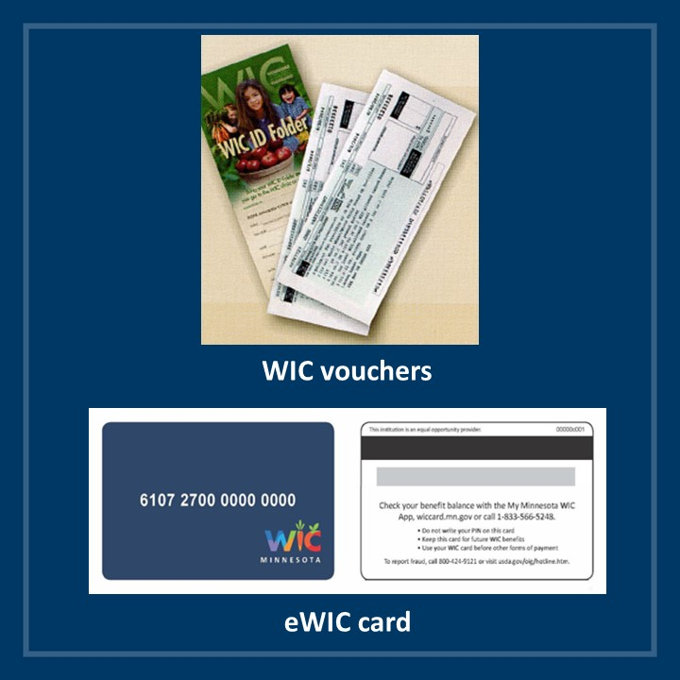

Planning an event
MN WIC encourages local agencies to celebrate the 50th anniversary in their community by hosting an event. These can be for WIC staff, partners, and even include media. MN WIC has put together resources for local agencies interested in promoting their clinic and highlighting the program’s 50th anniversary.
Local agencies wanting state MN WIC staff involvement should contact their state consultant for assistance.

News release template
MN WIC hosted an event and distributed a news release to statewide media in September to mark the 50th anniversary of the WIC program.
- Health leaders celebrate 50 years of improved health and nutrition for Minnesota families
Local agencies may be interested in highlighting their own clinic’s modernization and work with WIC families considering the 50th anniversary. A news release template is available on the WIC Communications & Outreach webpage.
- WIC 50th Anniversary News Release Template 2024 (WORD)

Talking points for events
MN WIC put together talking points local agencies can use for speakers at a 50th anniversary event. These can be adjusted to meet the event speaker’s needs.

Key talking point messages
- It’s incredible to look back at five decades of the WIC program and think about how far we’ve come and how many families we’ve supported through the early stages of parenthood.
- I would also like to talk about the future. How we continue to modernize to meet the needs of our current and future WIC families.
- WIC participants buy and eat more fruits, vegetables, whole grains, and low-fat dairy products thanks to the improved WIC food package that closely aligns to current dietary guidance.
- The WIC food packages provide supplemental foods designed to address the specific nutritional needs of participants.
- WIC participants receive a monthly benefit from one of seven science-based food packages, according to their life stage nutritional needs.
- Participants then use their WIC card to buy the food and beverages provided in their package from stores in the community.
- The food package has changed periodically over the past 50 years, evolving to meet modern nutrition science recommendations.
- It has grown from a basic package including dairy, juice, cereal and proteins like peanut butter or beans to a more robust and appealing supplemental food package.
- Participants receive fresh produce, milk, cheese, yogurt, whole grains and more. There are even dairy alternatives available.
- And more changes are coming. The USDA approved significant food package changes that we’re working hard to make available to families.
- Participants already receive increased food and vegetable benefit dollars and can look forward to more non-dairy substitutes for milk and more whole grain options to support wider personal and cultural food preferences.
- Access to the WIC Program is important. We are making it even simpler for Minnesotans to apply for WIC. The WIC online application is available in multiple languages and is an easy-to-use tool to help families determine if they’re eligible for WIC.
- The pandemic highlighted the need to be able to provide remote services. This ultimately led to a USDA-waiver WIC is using to give families flexibility of remote appointments – as long as they provide required measurements from a health professional within a set timeframe.
- We know the shopping experience is a big part of families receiving their WIC benefits and want it to be as positive and convenient as possible for families.
- We developed and launched the My MN WIC app eight years ago.
- Participants can register and find their benefit balance in the app. Shopping is less overwhelming using the app’s food finder to scan foods to see if they’re WIC allowed and available on a participant’s benefits versus finding out at check out.
- We can communicate directly with participants through app notifications and send appointment reminders. It’s a one-stop resource for our families.
- Families use the WIC card to scan and receive their WIC food benefits at the store. It launched in 2019, replacing the paper vouchers families used to use at checkout.
- The eWIC card is a more discreet and easier option for families to include WIC foods in their shopping trips.
- We know shopping with young children can be challenging and want our WIC families to enjoy the convenient options available to all shoppers.
- During the covid-19 pandemic, WIC worked with Walmart and Hy-Vee stores to make self-checkout an option for those shopping for WIC benefits.
- This year we’re also piloting an online shopping option with most Hy-Vee stores in Minnesota – making us one of the first states to make online shopping a reality for WIC families. Online shopping makes it easier for parents to access healthy foods, saving them the time and hassle of loading their kids in the shopping cart to shop in store.
- This option was made possible by a partnership with Iowa WIC, Nebraska WIC, and online WIC EBT with the support of a sub-grant from the Center for Nutrition and Health Impact. Our hope is that online shopping options grow in the future, making shopping even easier for our families.
- Breastfeeding is also a priority for the WIC program. It benefits babies and parents. WIC has always provided one-on-one support before and during a parent’s breastfeeding journey to help parent’s reach their goals.
- In 2005, WIC launched the Peer Breastfeeding Support Program. This improved how WIC was meeting the needs of new parents and helping them successfully initiate and continue breastfeeding their babies.
- Breastfeeding is different for everyone. Building a support system that’s tailored to a new parent’s needs is a key to success. We’re proud to have peer breastfeeding counselors throughout the state at many local agencies.
- Peers are past or current WIC participants with personal breastfeeding experience. They’re from the community they support. Many times, they help with language barriers. They understand cultural breastfeeding practices and beliefs.
- Our peers are making a difference. WIC participants who had contact with a peer were more likely to initiate breastfeeding and less likely to wean at any time during the baby’s first year of life.
- As the WIC program marks this milestone- we honor those in the past who had the foresight to start the program and look forward to another 50 years of helping Minnesota families thrive!

Reference – Complete Listing of Hyperlinks
WIC 50th Anniversary (https://www.health.state.mn.us/people/wic/localagency/celebrate50.html)
Minnesota WIC 50th Anniversary (YouTube) (https://www.youtube.com/watch?v=gC6FOEECFGo)
MN WIC Facebook (https://www.facebook.com/MNWIC)
MN WIC Instagram (https://www.instagram.com/minnesotawic)
National WIC Association Celebrating 50 years of WIC (https://wic50th.nwica.org/)
U.S. Department of Agriculture 50th Anniversary of WIC (https://wicworks.fns.usda.gov/50th-anniversary-wic)
Health leaders celebrate 50 years of improved health and nutrition for Minnesota families (https://www.health.state.mn.us/news/pressrel/2024/wic090524.html)
WIC Communications & Outreach (https://www.health.state.mn.us/people/wic/localagency/comm.html#news)
WIC and Health Care Providers (https://www.health.state.mn.us/people/wic/hcp/index.html)
Welcome to WIC (https://www.health.state.mn.us/people/wic/ppthome.html)
Apply for WIC (https://redcap.health.state.mn.us/redcap/surveys/?s=4WCPLJL77MLKRPJ3)
WIC 50th Anniversary News Release Template 2024 (WORD) (https://www.health.state.mn.us/docs/people/wic/localagency/comm/wic50releasetemplate.docx)
Minnesota Department of Health - WIC Program, 625 Robert St. N, PO BOX 64975, ST PAUL MN 55164-0975; 1-800-657-3942, health.wic@state.mn.us, www.health.state.mn.us; to obtain this information in a different format, call: 1-800-657-3942.
This institution is an equal opportunity provider.

