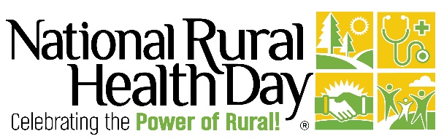
YOUR ORGANIZATION LOGO HERE

Contact:
[Your Name]
[Your Organization Name]
[Phone Number]
[Email Address]
Release Date: [Insert Date]
[ORGANIZATION] Celebrates National Rural Health Day on November 20, 2025
[CITY, STATE, Month Date] — [Organization Name] is proud to join communities across the country in celebrating National Rural Health Day (NRHD) on Thursday, November 20, 2025. Since 2011, this annual observance — founded and coordinated by the National Organization of State Offices of Rural Health (https://nosorh.org/) (NOSORH), has been held on the third Thursday of November to spotlight the unique healthcare challenges and remarkable strength of the nearly 61 million people living in rural America.
“Rural communities are the backbone of our state, and their health is vital to our collective future,” said [Name, Title], [Organization Name]. “We’re proud to celebrate National Rural Health Day and honor the unwavering commitment of rural healthcare providers, organizations, and community leaders who work every day to improve the lives of others.”
This year, [Organization Name] is marking the occasion by [briefly describe activity, event, or initiative—e.g., hosting a health fair, honoring a rural health champion, or joining the nationwide #PowerOfRural social media campaign]. Community members, partners, and stakeholders are encouraged to participate and help highlight rural health's impact in [Your State or Region].
For more information about National Rural Health Day and how to get involved, visit PowerOfRural.org.
To learn more about [Organization Name], visit [Organization Website].

###

